**QUIZ MANAGEMENT SYSTEM**



An

Object-Oriented Programming through Java Course Project Report

in partial fulfilment of the degree

**Bachelor of Technology**

in

**Computer Science & Engineering**

**By**

GADDAM SHIVA KUMAR 2103A51L10

YARRABOINA KARTHIK 2103A51L35

**Under the Guidance of**

Mr. K. Ravi Chythanya

Assistant Professor, Department of CSE

**Submitted to**



v



**SCHOOL OF COMPUTER SCIENCE & ARTIFICIAL INTELLIGENCE**

**CERTIFICATE**

This is to certify that the **Object Oriented Programming through Java Course Project Report entitled “QUIZ MANAGEMENT SYSTEM”** is a record of bonafide work carried out by the students **G.ShivaKumar, Y.Karthik** bearing Roll No(s) **2103A51L10,2103A51L35**during the academic year 2022-23 in partial fulfillment of the award of the degree of **Bachelor of Technology** in **Computer Science & Engineering** by the SR University, Warangal.

**Lab in-charge Head of the Department**

**TABLE OF CONTENTS**

|  |  |  |
| --- | --- | --- |
| **S. No** | **Title** | **Page. No** |
|  | Abstract | 4 |
| 1 | Objective of the project | 5 |
| 2 | Definitions of the elements used in the project | 6-7 |
| 3 | Design | 8-13 |
| 4 | Implementation | 14-80 |
| 5 | Result Screens | 81-83 |
| 6 | Conclusion | 84 |

**ABSTRACT**

The project: "QUIZ MANAGEMENT SYSTEM" is a collection of number of different types of quizzes like technical, games, sports, etc. A user can access/play all of the quiz and can attempt any of the one. There will be limited number of questions and for each correct answer user will get a credit score. User can see answers as well as can ask a query related to it. There are many quiz applications available currently on internet. But there are few Which provide better understanding between users and the application like, providing proper answers, user query solving, uploading user questions as well as answer to it, etc.

To develop a user friendly quiz application which will contain: Numbers of quiz, Answers to every question, Query solving regarding any question, Uploading of user question and answer, and to improve the knowledge level of users. To develop a application which will contain solution to the above problems. By this application the user will come to know about his/her level and can learn additional knowledge. Also by this application a user can expand his/her knowledge among the world.

1. **OBJECTIVE OF THE PROJECT**

Quiz Management System is an online application, from which user can easily manage Academic details, Performance details, Quiz details. Admin can track all the information of Academic, Score, Performance etc. Admin can edit, add, delete and update the records of Quiz, Participate, Winner.

This application provides facility to Play quiz and practice Grammar, Aptitude, and G.K. It provides a good platform, where a student not only judges there knowledge/skill but also they can improve knowledge/skill at the same time.

1. **DEFINITIONS OF THE ELEMENTS USED IN THE PROJECT**

|  |  |
| --- | --- |
| **AWT classes** | **Description** |
| AWT Event | Encapsulates AWT events |
| Border Layout | The border layout manager |
| Button | Creates a push button control |
| Checkbox | Creates checkbox control |
| Container | A subclass of Component that can hold other components |
| Color | Manages colors in a portable |
| Label | Creates a label that displays a string |
| Menu Bar | Creates a menu bar |
| Scrollbar | Creates a scroll bar control |
| Text Area | Creates a Multiline edit control |
| Text Field | Creates a single-line edit control |
| Dialog | Creates a Dialog window |
| Frame | Creates a standard window that has title bar,resize corners and a menu bar |
| Font | Encapsulates a type font |

|  |  |  |  |
| --- | --- | --- | --- |
| **Event Class** | **Event Sources** | **Event Listener** | **Methods in them** |
| Action event | Pressing a button ,List Item, Menu Item, Text Field | Action Listener | action Performed( ) |
| Focus event | A component gains or loses focus | Focus Listener | focus Gained( ) |
| Mouse event | Mouse button is clicked ,pressed or released.Mouse pointer enters leaves  a component | Mouse  Listener | mouse Clicked( )  mouse Entered( )  mouse Exited( )  mouse Pressed( )  mouse Released( ) |

**All the used Event Classes, Event Sources, Event Listener Interfaces &methods**

1. **DESIGN**
   1. SCREENS

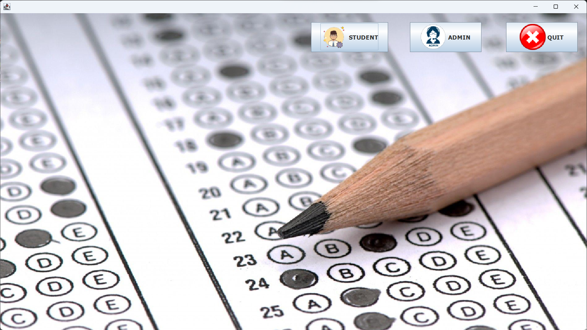

Home Page

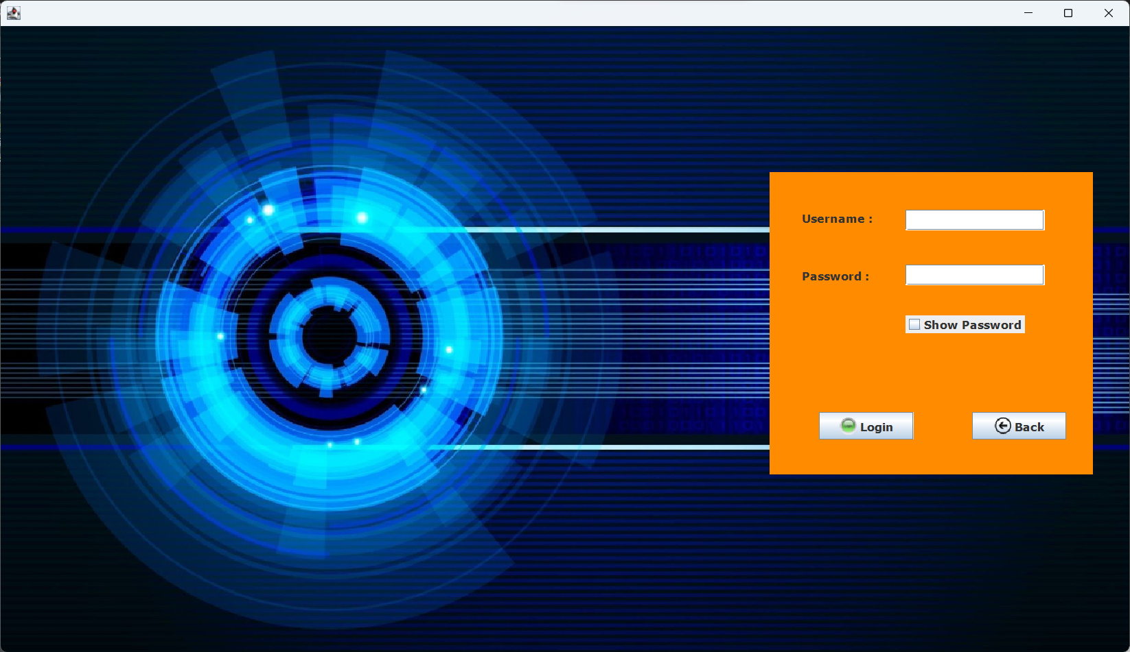

Admin Login Page

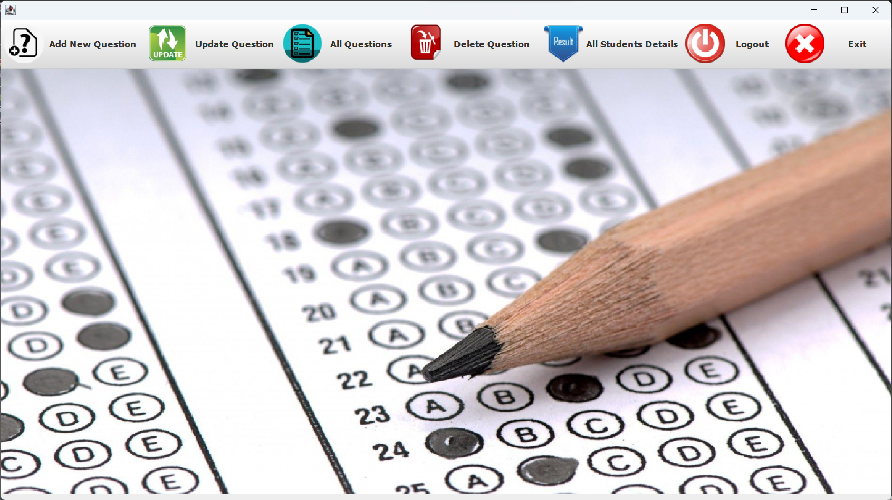

Admin Page

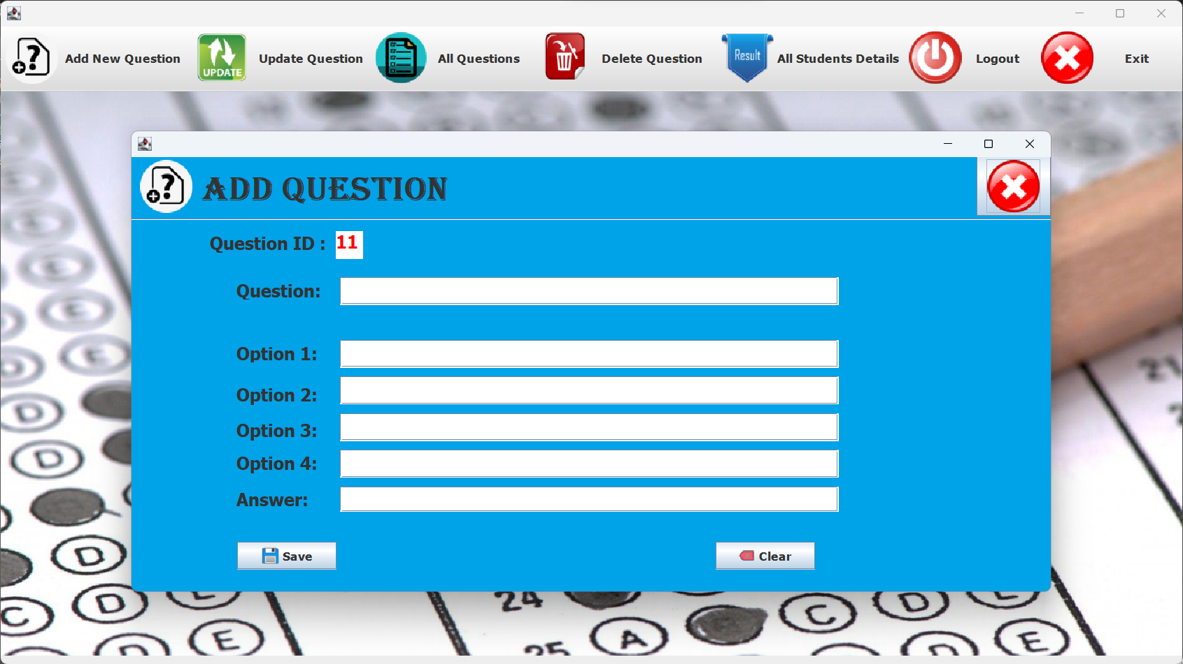

Add Question Page

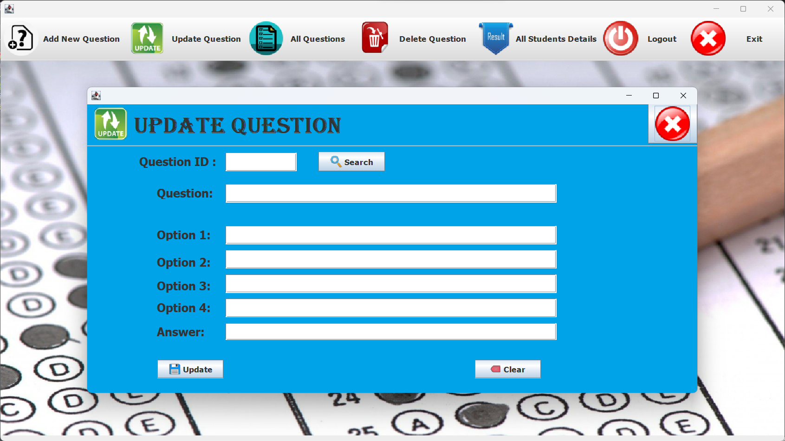

Update Question Page

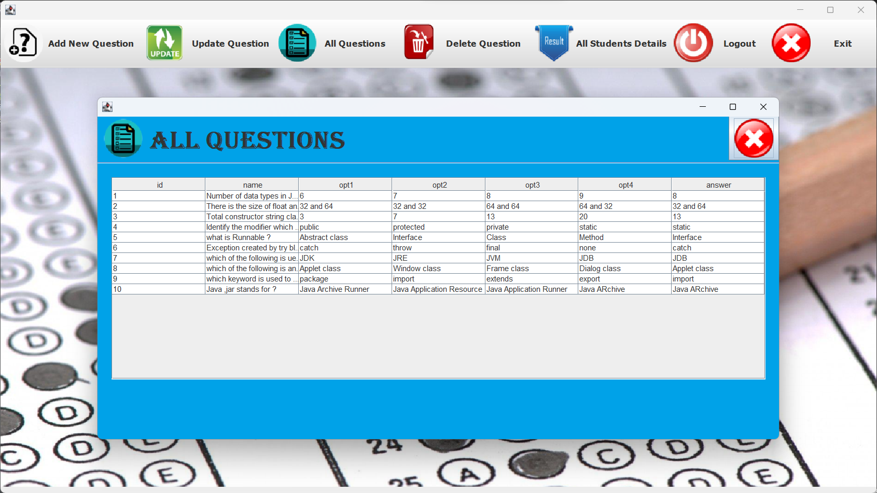

All Questions Page

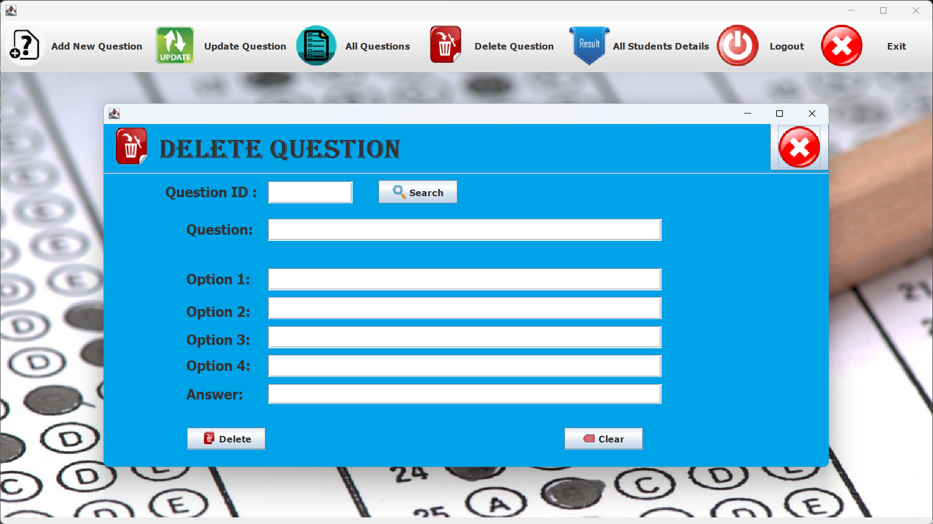

Delete Question Page

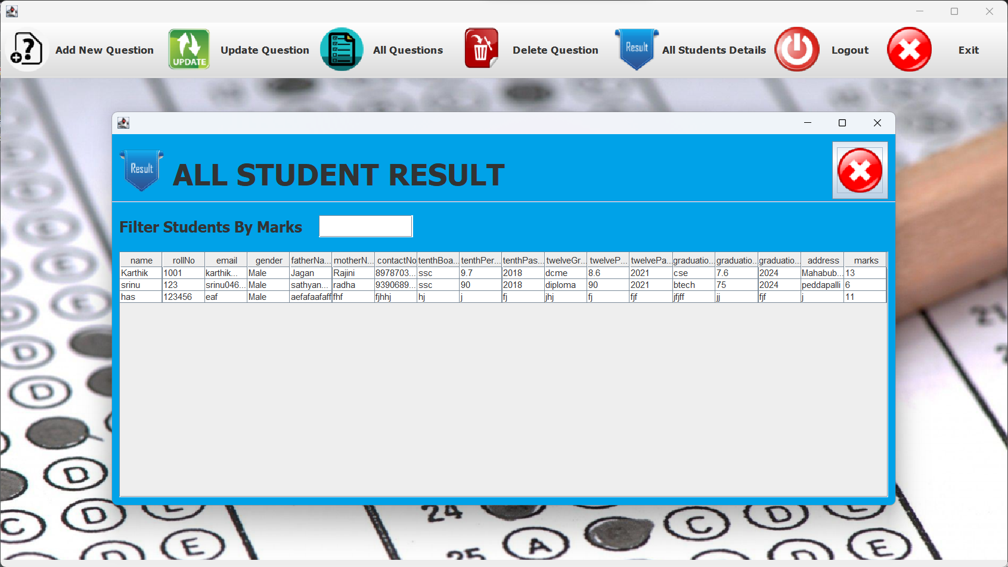

All Student Result Page

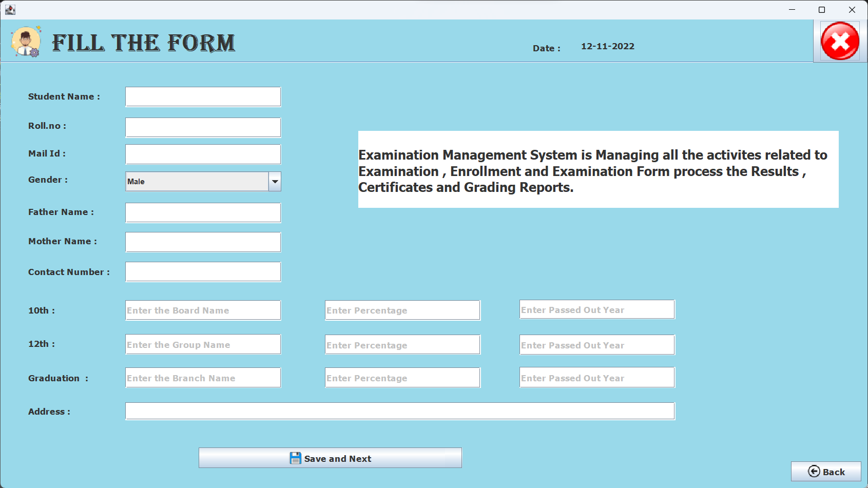

Student Registration Form Page

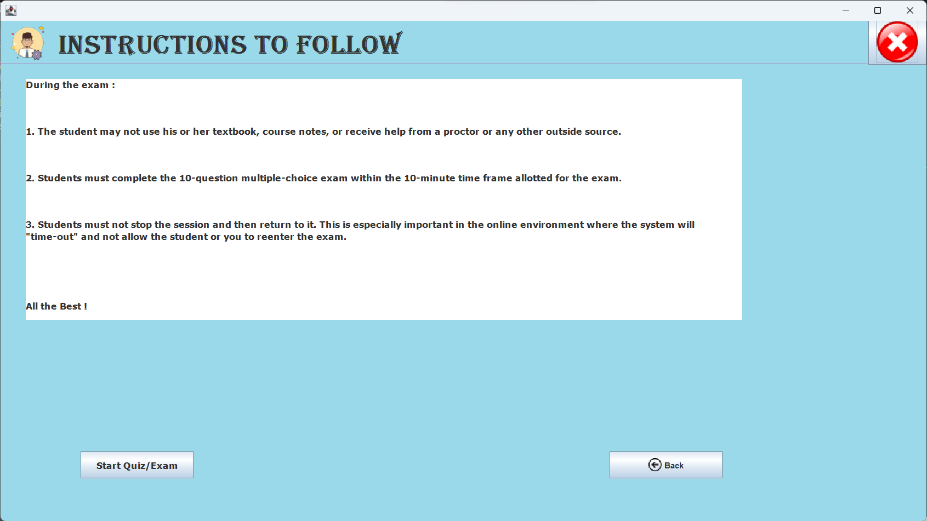

Student Instructions Page

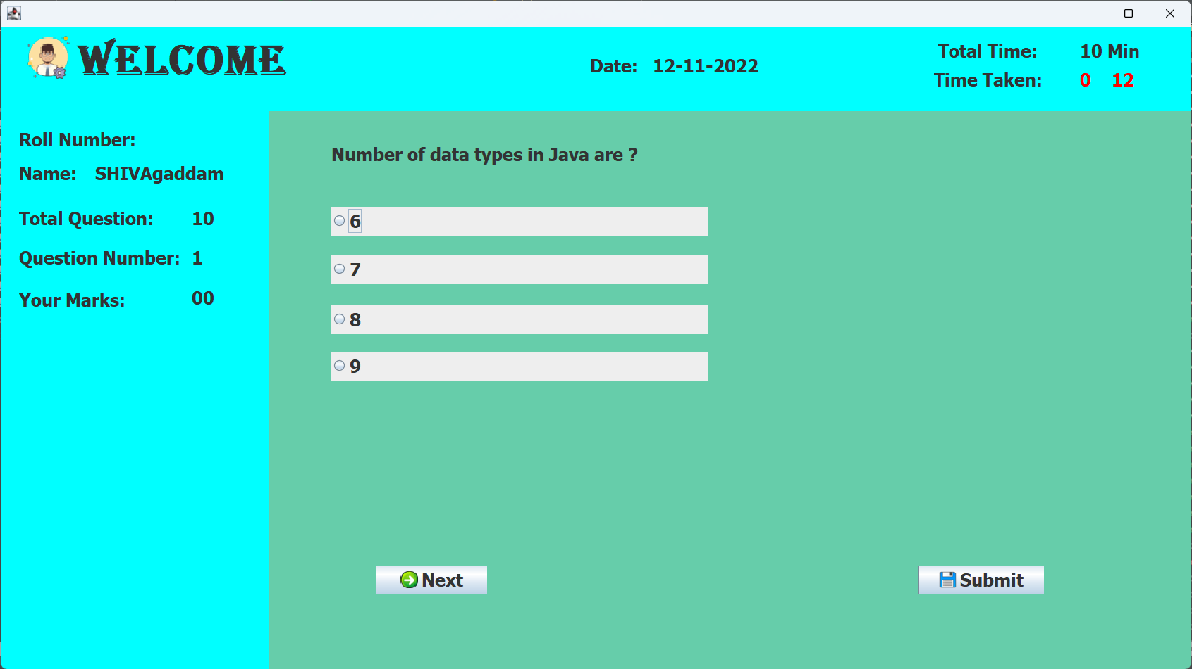

Student Quiz Page

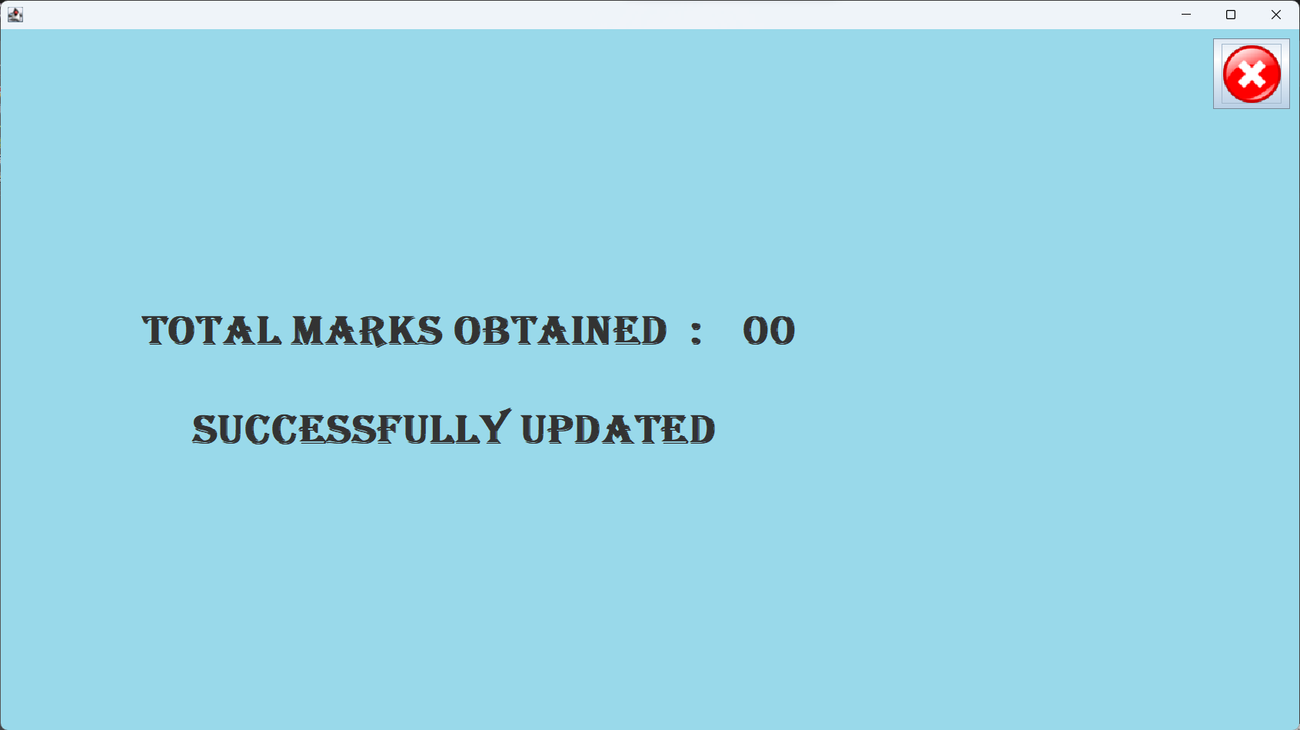

Student Result Page

1. **IMPLEMENTATION**

4.1 Code:

**Home Page code:**

import java.awt.EventQueue;

import javax.swing.JFrame;

import javax.swing.JButton;

import javax.swing.ImageIcon;

import javax.swing.JLabel;

import javax.swing.JOptionPane;

import java.awt.Font;

import java.awt.event.ActionListener;

import java.awt.event.ActionEvent;

public class Home_page {

JFrame frame;

/**

* Launch the application.

*/

public static void main(String[] args) {

EventQueue.invokeLater(new Runnable() {

public void run() {

try {

Home_page window = new Home_page ();

window.frame.setVisible(true);

} catch (Exception e) {

e.printStackTrace();

}

}

});

}

/**

* Create the application.

*/

public Home_page () {

initialize();

}

/**

* Initialize the contents of the frame.

*/

private void initialize() {

frame = new JFrame();

frame.setBounds(0, 0, 1366, 768);

frame.setDefaultCloseOperation(JFrame.EXIT_ON_CLOSE);

frame.getContentPane().setLayout(null);

JButton btnNewButton = new JButton("QUIT");

btnNewButton.addActionListener(new ActionListener() {

public void actionPerformed(ActionEvent e) {

int a =JOptionPane.showConfirmDialog(null,"Do you want to close the Application","select",JOptionPane.YES_NO_OPTION);

if(a==0)

{

System.exit(0);

}

}

});

btnNewButton.setFont(new Font("Tahoma", Font.BOLD, 14));

btnNewButton.setIcon(new ImageIcon("C:\\Users\\yerra\\Dropbox\\PC\\Desktop\\quiz\\Close.png"));

btnNewButton.setBounds(1166, 21, 165, 69);

frame.getContentPane().add(btnNewButton);

JButton btnNewButton_1 = new JButton("ADMIN");

btnNewButton_1.addActionListener(new ActionListener() {

public void actionPerformed(ActionEvent e) {

Admin_login_page alp= new Admin_login_page();

alp.frame.setVisible(true);

frame.dispose();

}

});

btnNewButton_1.setFont(new Font("Tahoma", Font.BOLD, 14));

btnNewButton_1.setIcon(new ImageIcon("C:\\Users\\yerra\\Dropbox\\PC\\Desktop\\quiz\\index admin.png"));

btnNewButton_1.setBounds(944, 21, 165, 69);

frame.getContentPane().add(btnNewButton_1);

JButton btnNewButton_1_1 = new JButton("STUDENT");

btnNewButton_1_1.addActionListener(new ActionListener() {

public void actionPerformed(ActionEvent e) {

Student_details sd=new Student_details();

sd.frame.setVisible(true);

frame.dispose();

}

});

btnNewButton_1_1.setFont(new Font("Tahoma", Font.BOLD, 14));

btnNewButton_1_1.setIcon(new ImageIcon("C:\\Users\\yerra\\Dropbox\\PC\\Desktop\\quiz\\index student.png"));

btnNewButton_1_1.setBounds(716, 21, 178, 69);

frame.getContentPane().add(btnNewButton_1_1);

JLabel lblNewLabel = new JLabel("");

lblNewLabel.setIcon(new ImageIcon("C:\\Users\\yerra\\Dropbox\\PC\\Desktop\\quiz\\index background.png"));

lblNewLabel.setBounds(0, 0, 1352, 731);

frame.getContentPane().add(lblNewLabel);

}

public void setVisible(boolean b) {

// TODO Auto-generated method stub

}

}

**Admin Login Page Code**:

import java.awt.EventQueue;

import javax.swing.JFrame;

import javax.swing.JLabel;

import javax.swing.JOptionPane;

import javax.swing.ImageIcon;

import java.awt.Font;

import javax.swing.JTextField;

import javax.swing.UIManager;

import javax.swing.JCheckBox;

import javax.swing.JButton;

import javax.swing.JPasswordField;

import java.awt.event.ActionListener;

import java.awt.event.ActionEvent;

import javax.swing.JPanel;

import java.awt.Color;

public class Admin_login_page {

JFrame frame;

private JTextField textField;

private JPasswordField passwordField;

/**

* Launch the application.

*/

public static void main(String[] args) {

EventQueue.invokeLater(new Runnable() {

public void run() {

try {

Admin_login_page window = new Admin_login_page();

window.frame.setVisible(true);

} catch (Exception e) {

e.printStackTrace();

}

}

});

}

/**

* Create the application.

*/

public Admin_login_page() {

initialize();

}

/**

* Initialize the contents of the frame.

*/

private void initialize() {

frame = new JFrame();

frame.setBounds(0, 0, 1330, 768);

frame.setDefaultCloseOperation(JFrame.EXIT_ON_CLOSE);

frame.getContentPane().setLayout(null);

JLabel lblNewLabel_1 = new JLabel("Username :");

lblNewLabel_1.setFont(new Font("Tahoma", Font.BOLD, 14));

lblNewLabel_1.setBounds(934, 203, 92, 42);

frame.getContentPane().add(lblNewLabel_1);

JLabel lblNewLabel_2 = new JLabel("Password :");

lblNewLabel_2.setFont(new Font("Tahoma", Font.BOLD, 14));

lblNewLabel_2.setBounds(934, 279, 92, 24);

frame.getContentPane().add(lblNewLabel_2);

textField = new JTextField();

textField.setBounds(1055, 215, 162, 24);

frame.getContentPane().add(textField);

textField.setColumns(10);

passwordField = new JPasswordField();

passwordField.setBounds(1055, 279, 162, 24);

frame.getContentPane().add(passwordField);

JCheckBox chckbxNewCheckBox = new JCheckBox("Show Password");

chckbxNewCheckBox.addActionListener(new ActionListener() {

public void actionPerformed(ActionEvent e) {

JCheckBox c=(JCheckBox) e.getSource();

passwordField.setEchoChar(c.isSelected()?'\u0000' : (Character) UIManager.get("PasswordField.echoChar"));

}

});

chckbxNewCheckBox.setFont(new Font("Tahoma", Font.BOLD, 14));

chckbxNewCheckBox.setBounds(1055, 338, 139, 21);

frame.getContentPane().add(chckbxNewCheckBox);

JButton btnBack = new JButton("Back");

btnBack.addActionListener(new ActionListener() {

public void actionPerformed(ActionEvent e) {

Home_page hp =new Home_page();

hp.frame.setVisible(true);

frame.dispose();

}

});

btnBack.setFont(new Font("Tahoma", Font.BOLD, 14));

btnBack.setIcon(new ImageIcon("C:\\Users\\yerra\\Dropbox\\PC\\Desktop\\quiz\\Back.png"));

btnBack.setBounds(1132, 451, 110, 32);

frame.getContentPane().add(btnBack);

JButton btnNewButton = new JButton("Login");

btnNewButton.addActionListener(new ActionListener() {

@SuppressWarnings("deprecation")

public void actionPerformed(ActionEvent e) {

String name=textField.getText();

String password=passwordField.getText();

if(name.equalsIgnoreCase("gsyk")&& password.equalsIgnoreCase("admin"))

{

Admin_page ap=new Admin_page();

ap.frame.setVisible(true);

frame.dispose();

}

else

{

JOptionPane.showMessageDialog(null,"Incorrect Username and Password.\n Try again");

}

}

});

btnNewButton.setFont(new Font("Tahoma", Font.BOLD, 14));

btnNewButton.setIcon(new ImageIcon("C:\\Users\\yerra\\Dropbox\\PC\\Desktop\\quiz\\login.png"));

btnNewButton.setBounds(954, 451, 110, 32);

frame.getContentPane().add(btnNewButton);

JPanel panel = new JPanel();

panel.setBackground(new Color(255, 140, 0));

panel.setForeground(new Color(0, 0, 0));

panel.setBounds(896, 171, 377, 353);

frame.getContentPane().add(panel);

JLabel lblNewLabel = new JLabel("");

lblNewLabel.setBackground(new Color(0, 0, 128));

lblNewLabel.setIcon(new ImageIcon("C:\\Users\\yerra\\Dropbox\\PC\\Desktop\\quiz\\Untitled.png"));

lblNewLabel.setBounds(0, 0, 1316, 731);

frame.getContentPane().add(lblNewLabel);

}

}

**Admin Page Code:**

import java.awt.EventQueue;

import javax.swing.JFrame;

import javax.swing.JMenuBar;

import javax.swing.JOptionPane;

import javax.swing.JMenu;

import javax.swing.ImageIcon;

import java.awt.Font;

import java.awt.Insets;

import javax.swing.JLabel;

import java.awt.event.MouseAdapter;

import java.awt.event.MouseEvent;

public class Admin_page {

JFrame frame;

public static int open=0;

/**

* Launch the application.

*/

public static void main(String[] args) {

EventQueue.invokeLater(new Runnable() {

public void run() {

try {

Admin_page window = new Admin_page();

window.frame.setVisible(true);

} catch (Exception e) {

e.printStackTrace();

}

}

});

}

/**

* Create the application.

*/

public Admin_page() {

initialize();

}

/**

* Initialize the contents of the frame.

*/

private void initialize() {

frame = new JFrame();

frame.setBounds(0, 0, 1366, 768);

frame.setDefaultCloseOperation(JFrame.EXIT_ON_CLOSE);

frame.getContentPane().setLayout(null);

JMenuBar menuBar = new JMenuBar();

menuBar.setBounds(0, 0, 1373, 75);

frame.getContentPane().add(menuBar);

JMenu mnNewMenu = new JMenu(" Add New Question ");

mnNewMenu.addMouseListener(new MouseAdapter() {

@Override

public void mouseClicked(MouseEvent e) {

if(open==0)

{

Add_question aq= new Add_question();

aq.frame.setVisible(true);

aq.frame.setAlwaysOnTop(true);

open=1;

}

else {

JFrame jf =new JFrame();

jf.setAlwaysOnTop(true);

JOptionPane.showMessageDialog(jf, "One Form Is Already Open");

}

}

});

mnNewMenu.setMargin(new Insets(0, 5, 0, 30));

mnNewMenu.setFont(new Font("Tahoma", Font.BOLD, 14));

mnNewMenu.setIcon(new ImageIcon("C:\\Users\\yerra\\Dropbox\\PC\\Desktop\\quiz\\add new question.png"));

menuBar.add(mnNewMenu);

JMenu mnUpdateQuestion = new JMenu(" Update Question");

mnUpdateQuestion.addMouseListener(new MouseAdapter() {

@Override

public void mouseClicked(MouseEvent e) {

if(open==0)

{

Update_question uq= new Update_question();

uq.frame.setVisible(true);

uq.frame.setAlwaysOnTop(true);

open=1;

}

else {

JFrame jf =new JFrame();

jf.setAlwaysOnTop(true);

JOptionPane.showMessageDialog(jf, "One Form Is Already Open");

}

}

});

mnUpdateQuestion.setFont(new Font("Tahoma", Font.BOLD, 14));

mnUpdateQuestion.setIcon(new ImageIcon("C:\\Users\\yerra\\Dropbox\\PC\\Desktop\\quiz\\Update Question.png"));

mnUpdateQuestion.setMargin(new Insets(0, 5, 0, 30));

menuBar.add(mnUpdateQuestion);

JMenu mnAllQuestions = new JMenu(" All Questions ");

mnAllQuestions.addMouseListener(new MouseAdapter() {

@Override

public void mouseClicked(MouseEvent e) {

if(open==0)

{

All_questions aq= new All_questions();

aq.frame.setVisible(true);

aq.frame.setAlwaysOnTop(true);

open=1;

}

else {

JFrame jf =new JFrame();

jf.setAlwaysOnTop(true);

JOptionPane.showMessageDialog(jf, "One Form Is Already Open");

}

}

});

mnAllQuestions.setIcon(new ImageIcon("C:\\Users\\yerra\\Dropbox\\PC\\Desktop\\quiz\\all questions.png"));

mnAllQuestions.setMargin(new Insets(0, 5, 0, 30));

mnAllQuestions.setFont(new Font("Tahoma", Font.BOLD, 14));

menuBar.add(mnAllQuestions);

JMenu mnDeleteQuestions = new JMenu(" Delete Question ");

mnDeleteQuestions.addMouseListener(new MouseAdapter() {

@Override

public void mouseClicked(MouseEvent e) {

if(open==0)

{

Delete_question dq= new Delete_question();

dq.frame.setVisible(true);

dq.frame.setAlwaysOnTop(true);

open=1;

}

else {

JFrame jf =new JFrame();

jf.setAlwaysOnTop(true);

JOptionPane.showMessageDialog(jf, "One Form Is Already Open");

}

}

});

mnDeleteQuestions.setIcon(new ImageIcon("C:\\Users\\yerra\\Dropbox\\PC\\Desktop\\quiz\\delete Question.png"));

mnDeleteQuestions.setMargin(new Insets(0, 5, 0, 30));

mnDeleteQuestions.setFont(new Font("Tahoma", Font.BOLD, 14));

menuBar.add(mnDeleteQuestions);

JMenu mnAllStudentsDetails = new JMenu("All Students Details");

mnAllStudentsDetails.addMouseListener(new MouseAdapter() {

@Override

public void mouseClicked(MouseEvent e) {

if(open==0)

{

All_Student_Results asr= new All_Student_Results ();

asr.frame.setAlwaysOnTop(true);

asr.frame.setVisible(true);

open=1;

}

else {

JFrame jf =new JFrame();

jf.setAlwaysOnTop(true);

JOptionPane.showMessageDialog(jf, "One Form Is Already Open");

}

}

});

mnAllStudentsDetails.setIcon(new ImageIcon("C:\\Users\\yerra\\Dropbox\\PC\\Desktop\\quiz\\all student result.png"));

mnAllStudentsDetails.setMargin(new Insets(0, 5, 0, 30));

mnAllStudentsDetails.setFont(new Font("Tahoma", Font.BOLD, 14));

menuBar.add(mnAllStudentsDetails);

JMenu mnLogout = new JMenu(" Logout ");

mnLogout.addMouseListener(new MouseAdapter() {

@Override

public void mouseClicked(MouseEvent e) {

JFrame jf=new JFrame();

jf.setAlwaysOnTop(true);

int a=JOptionPane.showConfirmDialog(jf, "Do you really want to Logout","select",JOptionPane.YES_NO_OPTION);

if(a==0)

{

Admin_login_page alp=new Admin_login_page();

alp.frame.setVisible(true);

frame.dispose();

}

}

});

mnLogout.setIcon(new ImageIcon("C:\\Users\\yerra\\Dropbox\\PC\\Desktop\\quiz\\Logout.png"));

mnLogout.setMargin(new Insets(0, 5, 0, 30));

mnLogout.setFont(new Font("Tahoma", Font.BOLD, 14));

menuBar.add(mnLogout);

JMenu mnExit = new JMenu(" Exit ");

mnExit.addMouseListener(new MouseAdapter() {

@Override

public void mouseClicked(MouseEvent e) {

JFrame jf=new JFrame();

jf.setAlwaysOnTop(true);

int a=JOptionPane.showConfirmDialog(jf, "Do you want to Exit from Admin Page","select",JOptionPane.YES_NO_OPTION);

if(a==0)

{

Home_page hp=new Home_page();

hp.frame.setVisible(true);

frame.dispose();

}

}

});

mnExit.setIcon(new ImageIcon("C:\\Users\\yerra\\Dropbox\\PC\\Desktop\\quiz\\Close.png"));

mnExit.setMargin(new Insets(0, 5, 0, 30));

mnExit.setFont(new Font("Tahoma", Font.BOLD, 14));

menuBar.add(mnExit);

JLabel lblNewLabel = new JLabel("");

lblNewLabel.setIcon(new ImageIcon("C:\\Users\\yerra\\Dropbox\\PC\\Desktop\\quiz\\index background.png"));

lblNewLabel.setBounds(0, 71, 1384, 650);

frame.getContentPane().add(lblNewLabel);

}

}

**Add Question Page Code:**

import java.awt.EventQueue;

import javax.swing.JFrame;

import java.awt.Point;

import javax.swing.JLabel;

import javax.swing.JOptionPane;

import javax.swing.ImageIcon;

import java.awt.Font;

import javax.swing.JButton;

import javax.swing.JSeparator;

import javax.swing.JTextArea;

import javax.swing.JTextField;

import project.ConnectionProvider;

import java.awt.event.ActionListener;

import java.sql.Connection;

import java.sql.PreparedStatement;

import java.sql.ResultSet;

import java.sql.Statement;

import java.awt.event.ActionEvent;

import java.awt.Color;

public class Add_question {

JFrame frame;

private JTextField textField;

private JTextField textField_1;

private JTextField textField_2;

private JTextField textField_3;

private JTextField textField_4;

private JTextField textField_5;

private JTextArea lblNewLabel_1_1;

/**

* Launch the application.

*/

public static void main(String[] args) {

EventQueue.invokeLater(new Runnable() {

public void run() {

try {

Add_question window = new Add_question();

window.frame.setVisible(true);

} catch (Exception e) {

e.printStackTrace();

}

}

});

}

/**

* Create the application.

*/

public Add_question() {

initialize();

try {

Connection con=ConnectionProvider.getCon();

Statement st=con.createStatement(ResultSet.TYPE_SCROLL_INSENSITIVE,ResultSet.CONCUR_READ_ONLY);

ResultSet rs=st.executeQuery("select count(id) from question");

if(rs.first())

{

int id=rs.getInt(1);

id=id+1;

String str=String.valueOf(id);

lblNewLabel_1_1.setText(str);

}

else {

lblNewLabel_1_1.setText("1");

}

}

catch(Exception e)

{

JFrame jf=new JFrame();

jf.setAlwaysOnTop(true);

JOptionPane.showMessageDialog(jf, e);

}

}

/**

* Initialize the contents of the frame.

*/

private void initialize() {

frame = new JFrame();

frame.getContentPane().setLocation(new Point(150, 183));

frame.setBounds(150, 150, 1066, 535);

frame.setDefaultCloseOperation(JFrame.EXIT_ON_CLOSE);

frame.getContentPane().setLayout(null);

JLabel lblNewLabel = new JLabel("");

lblNewLabel.setIcon(new ImageIcon("C:\\Users\\yerra\\Dropbox\\PC\\Desktop\\quiz\\add new question.png"));

lblNewLabel.setBounds(10, 0, 65, 68);

frame.getContentPane().add(lblNewLabel);

JLabel lblNewLabel_1 = new JLabel("Add Question");

lblNewLabel_1.setFont(new Font("Algerian", Font.BOLD, 40));

lblNewLabel_1.setBounds(80, 10, 411, 62);

frame.getContentPane().add(lblNewLabel_1);

JButton btnNewButton = new JButton("");

btnNewButton.addActionListener(new ActionListener() {

public void actionPerformed(ActionEvent e) {

Admin_page hp=new Admin_page();

Admin_page.open=0;

hp.frame.setVisible(false);

frame.dispose();

}

});

btnNewButton.setIcon(new ImageIcon("C:\\Users\\yerra\\Dropbox\\PC\\Desktop\\quiz\\Close.png"));

btnNewButton.setBounds(967, 0, 85, 68);

frame.getContentPane().add(btnNewButton);

JSeparator separator = new JSeparator();

separator.setBounds(0, 71, 1052, 13);

frame.getContentPane().add(separator);

JLabel lblNewLabel_2 = new JLabel("Question ID :");

lblNewLabel_2.setFont(new Font("Tahoma", Font.BOLD, 20));

lblNewLabel_2.setBounds(90, 88, 134, 22);

frame.getContentPane().add(lblNewLabel_2);

JLabel lblNewLabel_2_2 = new JLabel("Question:");

lblNewLabel_2_2.setFont(new Font("Tahoma", Font.BOLD, 20));

lblNewLabel_2_2.setBounds(120, 142, 131, 22);

frame.getContentPane().add(lblNewLabel_2_2);

JLabel lblNewLabel_2_3 = new JLabel("Option 1:");

lblNewLabel_2_3.setFont(new Font("Tahoma", Font.BOLD, 20));

lblNewLabel_2_3.setBounds(120, 214, 134, 22);

frame.getContentPane().add(lblNewLabel_2_3);

JLabel lblNewLabel_2_4 = new JLabel("Option 2:");

lblNewLabel_2_4.setFont(new Font("Tahoma", Font.BOLD, 20));

lblNewLabel_2_4.setBounds(120, 259, 114, 27);

frame.getContentPane().add(lblNewLabel_2_4);

JLabel lblNewLabel_2_5 = new JLabel("Option 3:");

lblNewLabel_2_5.setFont(new Font("Tahoma", Font.BOLD, 20));

lblNewLabel_2_5.setBounds(120, 300, 114, 27);

frame.getContentPane().add(lblNewLabel_2_5);

JLabel lblNewLabel_2_6 = new JLabel("Option 4:");

lblNewLabel_2_6.setFont(new Font("Tahoma", Font.BOLD, 20));

lblNewLabel_2_6.setBounds(120, 337, 107, 29);

frame.getContentPane().add(lblNewLabel_2_6);

JLabel lblNewLabel_2_7 = new JLabel("Answer:");

lblNewLabel_2_7.setFont(new Font("Tahoma", Font.BOLD, 20));

lblNewLabel_2_7.setBounds(120, 376, 114, 32);

frame.getContentPane().add(lblNewLabel_2_7);

textField = new JTextField();

textField.setFont(new Font("Tahoma", Font.PLAIN, 20));

textField.setBounds(239, 138, 570, 32);

frame.getContentPane().add(textField);

textField.setColumns(10);

textField_1 = new JTextField();

textField_1.setFont(new Font("Tahoma", Font.PLAIN, 20));

textField_1.setColumns(10);

textField_1.setBounds(239, 210, 570, 32);

frame.getContentPane().add(textField_1);

textField_2 = new JTextField();

textField_2.setFont(new Font("Tahoma", Font.PLAIN, 20));

textField_2.setColumns(10);

textField_2.setBounds(239, 252, 570, 32);

frame.getContentPane().add(textField_2);

textField_3 = new JTextField();

textField_3.setFont(new Font("Tahoma", Font.PLAIN, 20));

textField_3.setColumns(10);

textField_3.setBounds(239, 294, 570, 32);

frame.getContentPane().add(textField_3);

textField_4 = new JTextField();

textField_4.setFont(new Font("Tahoma", Font.PLAIN, 20));

textField_4.setColumns(10);

textField_4.setBounds(239, 336, 570, 32);

frame.getContentPane().add(textField_4);

textField_5 = new JTextField();

textField_5.setFont(new Font("Tahoma", Font.PLAIN, 20));

textField_5.setColumns(10);

textField_5.setBounds(239, 378, 570, 29);

frame.getContentPane().add(textField_5);

JButton btnNewButton_1 = new JButton("Save");

btnNewButton_1.addActionListener(new ActionListener() {

public void actionPerformed(ActionEvent e) {

String id=lblNewLabel_1_1.getText();

String name=textField.getText();

String opt1=textField_1.getText();

String opt2=textField_2.getText();

String opt3=textField_3.getText();

String opt4=textField_4.getText();

String answer=textField_5.getText();

try {

Connection con=ConnectionProvider.getCon();

PreparedStatement ps=con.prepareStatement("insert into question values(?,?,?,?,?,?,?)");

ps.setString(1, id);

ps.setString(2, name);

ps.setString(3, opt1);

ps.setString(4, opt2);

ps.setString(5, opt3);

ps.setString(6, opt4);

ps.setString(7, answer);

ps.executeUpdate();

JFrame jf=new JFrame();

jf.setAlwaysOnTop(true);

JOptionPane.showMessageDialog(jf, "Successfully Update");

jf.setVisible(false);

frame.dispose();

Add_question adp=new Add_question();

adp.frame.setVisible(true);

}

catch(Exception e1) {

JFrame jf=new JFrame();

jf.setAlwaysOnTop(true);

JOptionPane.showMessageDialog(jf,e1);

}

}

});

btnNewButton_1.setFont(new Font("Tahoma", Font.BOLD, 14));

btnNewButton_1.setIcon(new ImageIcon("C:\\Users\\yerra\\Dropbox\\PC\\Desktop\\quiz\\save.png"));

btnNewButton_1.setBounds(121, 441, 114, 32);

frame.getContentPane().add(btnNewButton_1);

JButton btnNewButton_1_1 = new JButton("Clear");

btnNewButton_1_1.addActionListener(new ActionListener() {

public void actionPerformed(ActionEvent e) {

textField.setText("");

textField_1.setText("");

textField_2.setText("");

textField_3.setText("");

textField_4.setText("");

textField_5.setText("");

}

});

btnNewButton_1_1.setFont(new Font("Tahoma", Font.BOLD, 14));

btnNewButton_1_1.setIcon(new ImageIcon("C:\\Users\\yerra\\Dropbox\\PC\\Desktop\\quiz\\clear.png"));

btnNewButton_1_1.setBounds(668, 441, 114, 32);

frame.getContentPane().add(btnNewButton_1_1);

lblNewLabel_1_1 = new JTextArea("00");

lblNewLabel_1_1.setForeground(new Color(255, 0, 0));

lblNewLabel_1_1.setFont(new Font("Tahoma", Font.BOLD, 20));

lblNewLabel_1_1.setBounds(234, 85, 31, 32);

lblNewLabel_1_1.setEditable(true);

frame.getContentPane().add(lblNewLabel_1_1);

JLabel lblNewLabel_3 = new JLabel("");

lblNewLabel_3.setIcon(new ImageIcon("C:\\Users\\yerra\\Dropbox\\PC\\Desktop\\quiz\\adminbg.png"));

lblNewLabel_3.setBounds(0, 0, 1052, 498);

frame.getContentPane().add(lblNewLabel_3);

}

}

**Update Question Page Code:**

import java.awt.EventQueue;

import javax.swing.JFrame;

import java.awt.Point;

import javax.swing.JLabel;

import javax.swing.JOptionPane;

import javax.swing.ImageIcon;

import java.awt.Font;

import javax.swing.JButton;

import javax.swing.JSeparator;

import javax.swing.JTextField;

import project.ConnectionProvider;

import java.awt.event.ActionListener;

import java.sql.Connection;

import java.sql.PreparedStatement;

import java.sql.ResultSet;

import java.sql.Statement;

import java.awt.event.ActionEvent;

public class Update_question {

JFrame frame;

private JTextField textField;

private JTextField textField_1;

private JTextField textField_2;

private JTextField textField_3;

private JTextField textField_4;

private JTextField textField_5;

private JTextField textField_6;

/**

* Launch the application.

*/

public static void main(String[] args) {

EventQueue.invokeLater(new Runnable() {

public void run() {

try {

Update_question window = new Update_question();

window.frame.setVisible(true);

} catch (Exception e) {

e.printStackTrace();

}

}

});

}

/**

* Create the application.

*/

public Update_question() {

initialize();

}

/**

* Initialize the contents of the frame.

*/

private void initialize() {

frame = new JFrame();

frame.getContentPane().setLocation(new Point(150, 183));

frame.setBounds(150, 150, 1066, 535);

frame.setDefaultCloseOperation(JFrame.EXIT_ON_CLOSE);

frame.getContentPane().setLayout(null);

JLabel lblNewLabel = new JLabel("");

lblNewLabel.setIcon(new ImageIcon("C:\\Users\\yerra\\Dropbox\\PC\\Desktop\\quiz\\Update Question.png"));

lblNewLabel.setBounds(10, 0, 65, 68);

frame.getContentPane().add(lblNewLabel);

JLabel lblNewLabel_1 = new JLabel("Update Question");

lblNewLabel_1.setFont(new Font("Algerian", Font.BOLD, 40));

lblNewLabel_1.setBounds(80, 10, 411, 62);

frame.getContentPane().add(lblNewLabel_1);

JButton btnNewButton = new JButton("");

btnNewButton.addActionListener(new ActionListener() {

public void actionPerformed(ActionEvent e) {

Admin_page hp=new Admin_page();

Admin_page.open=0;

hp.frame.setVisible(false);

frame.dispose();

}

});

btnNewButton.setIcon(new ImageIcon("C:\\Users\\yerra\\Dropbox\\PC\\Desktop\\quiz\\Close.png"));

btnNewButton.setBounds(967, 0, 85, 68);

frame.getContentPane().add(btnNewButton);

JSeparator separator = new JSeparator();

separator.setBounds(0, 71, 1052, 13);

frame.getContentPane().add(separator);

JLabel lblNewLabel_2 = new JLabel("Question ID :");

lblNewLabel_2.setFont(new Font("Tahoma", Font.BOLD, 20));

lblNewLabel_2.setBounds(90, 88, 134, 22);

frame.getContentPane().add(lblNewLabel_2);

JLabel lblNewLabel_2_2 = new JLabel("Question:");

lblNewLabel_2_2.setFont(new Font("Tahoma", Font.BOLD, 20));

lblNewLabel_2_2.setBounds(120, 142, 131, 22);

frame.getContentPane().add(lblNewLabel_2_2);

JLabel lblNewLabel_2_3 = new JLabel("Option 1:");

lblNewLabel_2_3.setFont(new Font("Tahoma", Font.BOLD, 20));

lblNewLabel_2_3.setBounds(120, 214, 134, 22);

frame.getContentPane().add(lblNewLabel_2_3);

JLabel lblNewLabel_2_4 = new JLabel("Option 2:");

lblNewLabel_2_4.setFont(new Font("Tahoma", Font.BOLD, 20));

lblNewLabel_2_4.setBounds(120, 259, 114, 27);

frame.getContentPane().add(lblNewLabel_2_4);

JLabel lblNewLabel_2_5 = new JLabel("Option 3:");

lblNewLabel_2_5.setFont(new Font("Tahoma", Font.BOLD, 20));

lblNewLabel_2_5.setBounds(120, 300, 114, 27);

frame.getContentPane().add(lblNewLabel_2_5);

JLabel lblNewLabel_2_6 = new JLabel("Option 4:");

lblNewLabel_2_6.setFont(new Font("Tahoma", Font.BOLD, 20));

lblNewLabel_2_6.setBounds(120, 337, 107, 29);

frame.getContentPane().add(lblNewLabel_2_6);

JLabel lblNewLabel_2_7 = new JLabel("Answer:");

lblNewLabel_2_7.setFont(new Font("Tahoma", Font.BOLD, 20));

lblNewLabel_2_7.setBounds(120, 376, 114, 32);

frame.getContentPane().add(lblNewLabel_2_7);

textField = new JTextField();

textField.setFont(new Font("Tahoma", Font.PLAIN, 20));

textField.setBounds(239, 138, 570, 32);

frame.getContentPane().add(textField);

textField.setColumns(10);

textField_1 = new JTextField();

textField_1.setFont(new Font("Tahoma", Font.PLAIN, 20));

textField_1.setColumns(10);

textField_1.setBounds(239, 210, 570, 32);

frame.getContentPane().add(textField_1);

textField_2 = new JTextField();

textField_2.setFont(new Font("Tahoma", Font.PLAIN, 20));

textField_2.setColumns(10);

textField_2.setBounds(239, 252, 570, 32);

frame.getContentPane().add(textField_2);

textField_3 = new JTextField();

textField_3.setFont(new Font("Tahoma", Font.PLAIN, 20));

textField_3.setColumns(10);

textField_3.setBounds(239, 294, 570, 32);

frame.getContentPane().add(textField_3);

textField_4 = new JTextField();

textField_4.setFont(new Font("Tahoma", Font.PLAIN, 20));

textField_4.setColumns(10);

textField_4.setBounds(239, 336, 570, 32);

frame.getContentPane().add(textField_4);

textField_5 = new JTextField();

textField_5.setFont(new Font("Tahoma", Font.PLAIN, 20));

textField_5.setColumns(10);

textField_5.setBounds(239, 378, 570, 29);

frame.getContentPane().add(textField_5);

JButton btnNewButton_1 = new JButton("Update");

btnNewButton_1.addActionListener(new ActionListener() {

public void actionPerformed(ActionEvent e) {

String id=textField_6.getText();

String name=textField.getText();

String opt1=textField_1.getText();

String opt2=textField_2.getText();

String opt3=textField_3.getText();

String opt4=textField_4.getText();

String answer=textField_5.getText();

try {

Connection con=ConnectionProvider.getCon();

PreparedStatement ps=con.prepareStatement("update Question set name=?,opt1=?,opt2=?,opt3=?,opt4=?,answer=? where id=?");

ps.setString(1, name);

ps.setString(2, opt1);

ps.setString(3, opt2);

ps.setString(4, opt3);

ps.setString(5, opt4);

ps.setString(6, answer);

ps.setString(7, id);

ps.executeUpdate();

JFrame jf=new JFrame();

jf.setAlwaysOnTop(true);

JOptionPane.showMessageDialog(jf,"Successfully Updated");

jf.setVisible(false);

frame.dispose();

Update_question up=new Update_question();

up.frame.setVisible(true);

}

catch(Exception e1)

{

JFrame jf=new JFrame();

jf.setAlwaysOnTop(true);

JOptionPane.showMessageDialog(jf,e1);

}

}

});

btnNewButton_1.setFont(new Font("Tahoma", Font.BOLD, 14));

btnNewButton_1.setIcon(new ImageIcon("C:\\Users\\yerra\\Dropbox\\PC\\Desktop\\quiz\\save.png"));

btnNewButton_1.setBounds(121, 441, 114, 32);

frame.getContentPane().add(btnNewButton_1);

JButton btnNewButton_1_1 = new JButton("Clear");

btnNewButton_1_1.addActionListener(new ActionListener() {

public void actionPerformed(ActionEvent e) {

textField_6.setText("");

textField.setText("");

textField_1.setText("");

textField_2.setText("");

textField_3.setText("");

textField_4.setText("");

textField_5.setText("");

textField_6.setEditable(true);

}

});

btnNewButton_1_1.setFont(new Font("Tahoma", Font.BOLD, 14));

btnNewButton_1_1.setIcon(new ImageIcon("C:\\Users\\yerra\\Dropbox\\PC\\Desktop\\quiz\\clear.png"));

btnNewButton_1_1.setBounds(668, 441, 114, 32);

frame.getContentPane().add(btnNewButton_1_1);

textField_6 = new JTextField();

textField_6.setFont(new Font("Tahoma", Font.PLAIN, 20));

textField_6.setColumns(10);

textField_6.setBounds(239, 84, 122, 32);

frame.getContentPane().add(textField_6);

JButton btnNewButton_2 = new JButton("Search");

btnNewButton_2.addActionListener(new ActionListener() {

public void actionPerformed(ActionEvent e) {

String id=textField_6.getText();

try {

Connection con=ConnectionProvider.getCon();

Statement st=con.createStatement(ResultSet.TYPE_SCROLL_INSENSITIVE,ResultSet.CONCUR_READ_ONLY);

ResultSet rs=st.executeQuery("select *from question where id='"+id+"'");

if(rs.first())

{

textField.setText(rs.getString(2));

textField_1.setText(rs.getString(3));

textField_2.setText(rs.getString(4));

textField_3.setText(rs.getString(5));

textField_4.setText(rs.getString(6));

textField_5.setText(rs.getString(7));

textField_6.setVisible(true);

}

else {

JFrame jf=new JFrame();

jf.setAlwaysOnTop(true);

JOptionPane.showMessageDialog(jf,"Qution id does not exist");

}

}

catch(Exception e1)

{

JFrame jf=new JFrame();

jf.setAlwaysOnTop(true);

JOptionPane.showMessageDialog(jf,e1);

}

}

});

btnNewButton_2.setFont(new Font("Tahoma", Font.BOLD, 14));

btnNewButton_2.setIcon(new ImageIcon("C:\\Users\\yerra\\Dropbox\\PC\\Desktop\\quiz\\search.png"));

btnNewButton_2.setBounds(399, 82, 114, 34);

frame.getContentPane().add(btnNewButton_2);

JLabel lblNewLabel_3 = new JLabel("");

lblNewLabel_3.setIcon(new ImageIcon("C:\\Users\\yerra\\Dropbox\\PC\\Desktop\\quiz\\adminbg.png"));

lblNewLabel_3.setBounds(0, 0, 1052, 498);

frame.getContentPane().add(lblNewLabel_3);

}

protected void setVisible(boolean b) {

// TODO Auto-generated method stub

}

}

**All Questions Page:**

import java.awt.EventQueue;

import javax.swing.JFrame;

import java.awt.Point;

import javax.swing.JLabel;

import javax.swing.JOptionPane;

import javax.swing.ImageIcon;

import java.awt.Font;

import javax.swing.JButton;

import javax.swing.JSeparator;

import java.awt.event.ActionListener;

import java.sql.Connection;

import java.sql.ResultSet;

import java.sql.Statement;

import java.awt.event.ActionEvent;

import javax.swing.JTable;

import net.proteanit.sql.DbUtils;

import project.ConnectionProvider;

import javax.swing.JScrollPane;

public class All_questions {

JFrame frame;

private JTable table;

/**

* Launch the application.

*/

public static void main(String[] args) {

EventQueue.invokeLater(new Runnable() {

public void run() {

try {

All_questions window = new All_questions();

window.frame.setVisible(true);

} catch (Exception e) {

e.printStackTrace();

}

}

});

}

/**

* Create the application.

*/

public All_questions() {

initialize();

try {

Connection con=ConnectionProvider.getCon();

Statement st=con.createStatement();

ResultSet rs=st.executeQuery("select *from question");

table.setModel(DbUtils.resultSetToTableModel(rs));

}

catch(Exception e) {

JOptionPane.showMessageDialog(null, e);

}

}

/**

* Initialize the contents of the frame.

*/

private void initialize() {

frame = new JFrame();

frame.getContentPane().setLocation(new Point(150, 183));

frame.setBounds(150, 150, 1066, 535);

frame.setDefaultCloseOperation(JFrame.EXIT_ON_CLOSE);

frame.getContentPane().setLayout(null);

JLabel lblNewLabel = new JLabel("");

lblNewLabel.setBounds(10, 0, 65, 68);

lblNewLabel.setIcon(new ImageIcon("C:\\Users\\yerra\\Dropbox\\PC\\Desktop\\quiz\\all questions.png"));

frame.getContentPane().add(lblNewLabel);

JLabel lblNewLabel_1 = new JLabel("All Questions");

lblNewLabel_1.setBounds(80, 10, 411, 62);

lblNewLabel_1.setFont(new Font("Algerian", Font.BOLD, 40));

frame.getContentPane().add(lblNewLabel_1);

JButton btnNewButton = new JButton("");

btnNewButton.setBounds(974, 0, 78, 68);

btnNewButton.addActionListener(new ActionListener() {

public void actionPerformed(ActionEvent e) {

Admin_page hp=new Admin_page();

Admin_page.open=0;

hp.frame.setVisible(false);

frame.dispose();

}

});

btnNewButton.setIcon(new ImageIcon("C:\\Users\\yerra\\Dropbox\\PC\\Desktop\\quiz\\Close.png"));

frame.getContentPane().add(btnNewButton);

JSeparator separator = new JSeparator();

separator.setBounds(0, 71, 1052, 13);

frame.getContentPane().add(separator);

JScrollPane scrollPane = new JScrollPane();

scrollPane.setBounds(22, 94, 1009, 312);

frame.getContentPane().add(scrollPane);

table = new JTable();

scrollPane.setViewportView(table);

JLabel lblNewLabel_3 = new JLabel("");

lblNewLabel_3.setBounds(0, 0, 1052, 498);

lblNewLabel_3.setFont(new Font("Tahoma", Font.BOLD, 20));

lblNewLabel_3.setIcon(new ImageIcon("C:\\Users\\yerra\\Dropbox\\PC\\Desktop\\quiz\\adminbg.png"));

frame.getContentPane().add(lblNewLabel_3);

}

}

**Delete Question Page Code:**

import java.awt.EventQueue;

import javax.swing.JFrame;

import java.awt.Point;

import javax.swing.JLabel;

import javax.swing.JOptionPane;

import javax.swing.ImageIcon;

import java.awt.Font;

import javax.swing.JButton;

import javax.swing.JSeparator;

import javax.swing.JTextField;

import project.ConnectionProvider;

import java.awt.event.ActionListener;

import java.sql.Connection;

import java.sql.PreparedStatement;

import java.sql.ResultSet;

import java.sql.Statement;

import java.awt.event.ActionEvent;

public class Delete_question {

JFrame frame;

private JTextField textField;

private JTextField textField_1;

private JTextField textField_2;

private JTextField textField_3;

private JTextField textField_4;

private JTextField textField_5;

private JTextField textField_6;

/**

* Launch the application.

*/

public static void main(String[] args) {

EventQueue.invokeLater(new Runnable() {

public void run() {

try {

Delete_question window = new Delete_question();

window.frame.setVisible(true);

} catch (Exception e) {

e.printStackTrace();

}

}

});

}

/**

* Create the application.

*/

public Delete_question() {

initialize();

}

/**

* Initialize the contents of the frame.

*/

private void initialize() {

frame = new JFrame();

frame.getContentPane().setLocation(new Point(150, 183));

frame.setBounds(150, 150, 1066, 535);

frame.setDefaultCloseOperation(JFrame.EXIT_ON_CLOSE);

frame.getContentPane().setLayout(null);

JLabel lblNewLabel = new JLabel("");

lblNewLabel.setIcon(new ImageIcon("C:\\Users\\yerra\\Dropbox\\PC\\Desktop\\quiz\\delete Question.png"));

lblNewLabel.setBounds(10, 0, 65, 68);

frame.getContentPane().add(lblNewLabel);

JLabel lblNewLabel_1 = new JLabel("Delete Question");

lblNewLabel_1.setFont(new Font("Algerian", Font.BOLD, 40));

lblNewLabel_1.setBounds(80, 10, 411, 62);

frame.getContentPane().add(lblNewLabel_1);

JButton btnNewButton = new JButton("");

btnNewButton.addActionListener(new ActionListener() {

public void actionPerformed(ActionEvent e) {

Admin_page hp=new Admin_page();

Admin_page.open=0;

hp.frame.setVisible(false);

frame.dispose();

}

});

btnNewButton.setIcon(new ImageIcon("C:\\Users\\yerra\\Dropbox\\PC\\Desktop\\quiz\\Close.png"));

btnNewButton.setBounds(967, 0, 85, 68);

frame.getContentPane().add(btnNewButton);

JSeparator separator = new JSeparator();

separator.setBounds(0, 71, 1052, 13);

frame.getContentPane().add(separator);

JLabel lblNewLabel_2 = new JLabel("Question ID :");

lblNewLabel_2.setFont(new Font("Tahoma", Font.BOLD, 20));

lblNewLabel_2.setBounds(90, 88, 134, 22);

frame.getContentPane().add(lblNewLabel_2);

JLabel lblNewLabel_2_2 = new JLabel("Question:");

lblNewLabel_2_2.setFont(new Font("Tahoma", Font.BOLD, 20));

lblNewLabel_2_2.setBounds(120, 142, 131, 22);

frame.getContentPane().add(lblNewLabel_2_2);

JLabel lblNewLabel_2_3 = new JLabel("Option 1:");

lblNewLabel_2_3.setFont(new Font("Tahoma", Font.BOLD, 20));

lblNewLabel_2_3.setBounds(120, 214, 134, 22);

frame.getContentPane().add(lblNewLabel_2_3);

JLabel lblNewLabel_2_4 = new JLabel("Option 2:");

lblNewLabel_2_4.setFont(new Font("Tahoma", Font.BOLD, 20));

lblNewLabel_2_4.setBounds(120, 259, 114, 27);

frame.getContentPane().add(lblNewLabel_2_4);

JLabel lblNewLabel_2_5 = new JLabel("Option 3:");

lblNewLabel_2_5.setFont(new Font("Tahoma", Font.BOLD, 20));

lblNewLabel_2_5.setBounds(120, 300, 114, 27);

frame.getContentPane().add(lblNewLabel_2_5);

JLabel lblNewLabel_2_6 = new JLabel("Option 4:");

lblNewLabel_2_6.setFont(new Font("Tahoma", Font.BOLD, 20));

lblNewLabel_2_6.setBounds(120, 337, 107, 29);

frame.getContentPane().add(lblNewLabel_2_6);

JLabel lblNewLabel_2_7 = new JLabel("Answer:");

lblNewLabel_2_7.setFont(new Font("Tahoma", Font.BOLD, 20));

lblNewLabel_2_7.setBounds(120, 376, 114, 32);

frame.getContentPane().add(lblNewLabel_2_7);

textField = new JTextField();

textField.setFont(new Font("Tahoma", Font.PLAIN, 20));

textField.setBounds(239, 138, 570, 32);

frame.getContentPane().add(textField);

textField.setColumns(10);

textField_1 = new JTextField();

textField_1.setFont(new Font("Tahoma", Font.PLAIN, 20));

textField_1.setColumns(10);

textField_1.setBounds(239, 210, 570, 32);

frame.getContentPane().add(textField_1);

textField_2 = new JTextField();

textField_2.setFont(new Font("Tahoma", Font.PLAIN, 20));

textField_2.setColumns(10);

textField_2.setBounds(239, 252, 570, 32);

frame.getContentPane().add(textField_2);

textField_3 = new JTextField();

textField_3.setFont(new Font("Tahoma", Font.PLAIN, 20));

textField_3.setColumns(10);

textField_3.setBounds(239, 294, 570, 32);

frame.getContentPane().add(textField_3);

textField_4 = new JTextField();

textField_4.setFont(new Font("Tahoma", Font.PLAIN, 20));

textField_4.setColumns(10);

textField_4.setBounds(239, 336, 570, 32);

frame.getContentPane().add(textField_4);

textField_5 = new JTextField();

textField_5.setFont(new Font("Tahoma", Font.PLAIN, 20));

textField_5.setColumns(10);

textField_5.setBounds(239, 378, 570, 29);

frame.getContentPane().add(textField_5);

JButton btnNewButton_1 = new JButton("Delete");

btnNewButton_1.addActionListener(new ActionListener() {

public void actionPerformed(ActionEvent e) {

String id=textField_6.getText();

try {

Connection con=ConnectionProvider.getCon();

PreparedStatement ps=con.prepareStatement("delete from question where id=?");

ps.setString(1, id);

ps.executeUpdate();

frame.setAlwaysOnTop(true);

JOptionPane.showMessageDialog(frame, "Successfully Deleted");

frame.setVisible(false);

frame.dispose();

Delete_question dq = new Delete_question();

dq.frame.setVisible(true);

}

catch(Exception e1)

{

frame.setAlwaysOnTop(true);

JOptionPane.showMessageDialog(frame, e);

}

}

});

btnNewButton_1.setFont(new Font("Tahoma", Font.BOLD, 14));

btnNewButton_1.setIcon(new ImageIcon("C:\\Users\\yerra\\Dropbox\\PC\\Desktop\\quiz\\delete.png"));

btnNewButton_1.setBounds(121, 441, 114, 32);

frame.getContentPane().add(btnNewButton_1);

JButton btnNewButton_1_1 = new JButton("Clear");

btnNewButton_1_1.setFont(new Font("Tahoma", Font.BOLD, 14));

btnNewButton_1_1.setIcon(new ImageIcon("C:\\Users\\yerra\\Dropbox\\PC\\Desktop\\quiz\\clear.png"));

btnNewButton_1_1.setBounds(668, 441, 114, 32);

frame.getContentPane().add(btnNewButton_1_1);

textField_6 = new JTextField();

textField_6.setFont(new Font("Tahoma", Font.PLAIN, 20));

textField_6.setColumns(10);

textField_6.setBounds(239, 84, 122, 32);

frame.getContentPane().add(textField_6);

JButton btnNewButton_2 = new JButton("Search");

btnNewButton_2.addActionListener(new ActionListener() {

public void actionPerformed(ActionEvent e) {

String id=textField_6.getText();

try {

Connection con=ConnectionProvider.getCon();

Statement st=con.createStatement(ResultSet.TYPE_SCROLL_INSENSITIVE,ResultSet.CONCUR_READ_ONLY);

ResultSet rs=st.executeQuery("select *from question where id='"+id+"'");

if(rs.first())

{

textField.setText(rs.getString(2));

textField_1.setText(rs.getString(3));

textField_2.setText(rs.getString(4));

textField_3.setText(rs.getString(5));

textField_4.setText(rs.getString(6));

textField_5.setText(rs.getString(7));

textField_6.setVisible(true);

}

else {

JFrame jf=new JFrame();

jf.setAlwaysOnTop(true);

JOptionPane.showMessageDialog(jf,"Question id does not exist");

}

}

catch(Exception e1)

{

JFrame jf=new JFrame();

jf.setAlwaysOnTop(true);

JOptionPane.showMessageDialog(jf,e1);

}

}

});

btnNewButton_2.setFont(new Font("Tahoma", Font.BOLD, 14));

btnNewButton_2.setIcon(new ImageIcon("C:\\Users\\yerra\\Dropbox\\PC\\Desktop\\quiz\\search.png"));

btnNewButton_2.setBounds(399, 82, 114, 34);

frame.getContentPane().add(btnNewButton_2);

JLabel lblNewLabel_3 = new JLabel("");

lblNewLabel_3.setIcon(new ImageIcon("C:\\Users\\yerra\\Dropbox\\PC\\Desktop\\quiz\\adminbg.png"));

lblNewLabel_3.setBounds(0, 0, 1052, 498);

frame.getContentPane().add(lblNewLabel_3);

}

}

**All Student Result Page Code:**

import java.awt.EventQueue;

import javax.swing.JFrame;

import java.awt.Point;

import javax.swing.JLabel;

import javax.swing.JOptionPane;

import javax.swing.ImageIcon;

import java.awt.Font;

import javax.swing.JButton;

import javax.swing.JSeparator;

import javax.swing.JTable;

import javax.swing.JTextField;

import net.proteanit.sql.DbUtils;

import project.ConnectionProvider;

import java.awt.Color;

import javax.swing.JScrollPane;

import java.awt.event.ActionListener;

import java.sql.Connection;

import java.sql.ResultSet;

import java.sql.Statement;

import java.awt.event.ActionEvent;

import java.awt.event.KeyAdapter;

import java.awt.event.KeyEvent;

public class All_Student_Results {

JFrame frame;

private JTextField textField;

private JTable table;

/**

* Launch the application.

*/

public static void main(String[] args) {

EventQueue.invokeLater(new Runnable() {

public void run() {

try {

All_Student_Results window = new All_Student_Results();

window.frame.setVisible(true);

} catch (Exception e) {

e.printStackTrace();

}

}

});

}

/**

* Create the application.

*/

public All_Student_Results() {

initialize();

try {

Connection con=ConnectionProvider.getCon();

Statement st=con.createStatement();

ResultSet rs=st.executeQuery("select *from student");

table.setModel(DbUtils.resultSetToTableModel(rs));

}

catch(Exception e) {

JOptionPane.showMessageDialog(null, e);

}

}

/**

* Initialize the contents of the frame.

*/

private void initialize() {

frame = new JFrame();

frame.getContentPane().setLocation(new Point(150, 183));

frame.setBounds(150, 150, 1066, 535);

frame.setDefaultCloseOperation(JFrame.EXIT_ON_CLOSE);

frame.getContentPane().setLayout(null);

JLabel lblNewLabel = new JLabel("");

lblNewLabel.setIcon(new ImageIcon("C:\\Users\\yerra\\Dropbox\\PC\\Desktop\\quiz\\all student result.png"));

lblNewLabel.setBounds(10, 10, 62, 78);

frame.getContentPane().add(lblNewLabel);

JLabel lblNewLabel_1 = new JLabel("ALL STUDENT RESULT");

lblNewLabel_1.setFont(new Font("Tahoma", Font.BOLD, 40));

lblNewLabel_1.setBounds(82, 19, 539, 69);

frame.getContentPane().add(lblNewLabel_1);

JButton btnNewButton = new JButton("");

btnNewButton.addActionListener(new ActionListener() {

public void actionPerformed(ActionEvent e) {

Admin_page hp=new Admin_page();

Admin_page.open=0;

hp.frame.setVisible(false);

frame.dispose();

}

});

btnNewButton.setIcon(new ImageIcon("C:\\Users\\yerra\\Dropbox\\PC\\Desktop\\quiz\\Close.png"));

btnNewButton.setBounds(967, 10, 75, 78);

frame.getContentPane().add(btnNewButton);

JSeparator separator = new JSeparator();

separator.setBounds(0, 90, 1052, 9);

frame.getContentPane().add(separator);

JLabel lblNewLabel_2 = new JLabel("Filter Students By Marks");

lblNewLabel_2.setFont(new Font("Tahoma", Font.BOLD, 20));

lblNewLabel_2.setBounds(10, 109, 254, 30);

frame.getContentPane().add(lblNewLabel_2);

textField = new JTextField();

textField.addKeyListener(new KeyAdapter() {

@Override

public void keyReleased(KeyEvent e) {

int marks;

if(textField.getText().equals(""))

{

marks=0;

}

else

{

marks=Integer.parseInt(textField.getText());

}

try {

Connection con=ConnectionProvider.getCon();

Statement st=con.createStatement();

ResultSet rs=st.executeQuery("select *from student where marks>="+marks+"");

table.setModel(DbUtils.resultSetToTableModel(rs));

}

catch(Exception e1) {

frame.setAlwaysOnTop(true);

JOptionPane.showMessageDialog(frame, e1);

}

}

});

textField.setFont(new Font("Tahoma", Font.BOLD, 20));

textField.setBounds(278, 109, 126, 30);

frame.getContentPane().add(textField);

textField.setColumns(10);

JScrollPane scrollPane = new JScrollPane();

scrollPane.setBounds(10, 158, 1032, 330);

frame.getContentPane().add(scrollPane);

table = new JTable();

scrollPane.setViewportView(table);

JLabel lblNewLabel_3 = new JLabel("");

lblNewLabel_3.setIcon(new ImageIcon("C:\\Users\\yerra\\Dropbox\\PC\\Desktop\\quiz\\adminbg.png"));

lblNewLabel_3.setBackground(Color.WHITE);

lblNewLabel_3.setBounds(0, 0, 1052, 498);

frame.getContentPane().add(lblNewLabel_3);

}

}

**Student Registration Form Page :**

import java.awt.EventQueue;

import java.awt.Font;

import java.awt.event.ActionEvent;

import java.awt.event.ActionListener;

import java.text.SimpleDateFormat;

import java.util.Date;

import javax.swing.ImageIcon;

import javax.swing.JButton;

import javax.swing.JFrame;

import javax.swing.JLabel;

import javax.swing.JOptionPane;

import javax.swing.JSeparator;

import javax.swing.JTextField;

import project.ConnectionProvider;

import javax.swing.JComboBox;

import javax.swing.DefaultComboBoxModel;

import javax.swing.JTextArea;

import java.awt.Color;

import java.awt.event.FocusAdapter;

import java.awt.event.FocusEvent;

import java.sql.Connection;

import java.sql.PreparedStatement;

public class Student_details {

JFrame frame;

private JTextField textField;

private JTextField textField_1;

private JTextField textField_2;

private JTextField textField_3;

private JTextField textField_4;

private JTextField textField_5;

private JTextField txtUniversityName;

private JTextField txtPercentage;

private JTextField txtPassedOutYear;

private JTextField txtUniversityName_1;

private JTextField txtPercentage_1;

private JTextField txtPassedOutYear_1;

private JTextField txtUniversityName_2;

private JTextField txtPercentage_2;

private JTextField txtPassedOutYear_2;

private JTextField textField_15;

private JTextArea txtrExaminationManagementSystem;

private JLabel lblNewLabel_3;

@SuppressWarnings("rawtypes")

private JComboBox comboBox;

/**

* Launch the application.

*/

public static void main(String[] args) {

EventQueue.invokeLater(new Runnable() {

public void run() {

try {

Student_details window = new Student_details();

window.frame.setVisible(true);

} catch (Exception e) {

e.printStackTrace();

}

}

});

}

/**

* Create the application.

*/

public Student_details() {

initialize();

txtrExaminationManagementSystem.setEditable(false);

SimpleDateFormat dFormat=new SimpleDateFormat("dd-MM-yyyy");

Date date=new Date();

lblNewLabel_3.setText(dFormat.format(date));

}

/**

* Initialize the contents of the frame.

*/

@SuppressWarnings({ "unchecked", "rawtypes" })

private void initialize() {

frame = new JFrame();

frame.setBounds(0, 0, 1366, 768);

frame.setDefaultCloseOperation(JFrame.EXIT_ON_CLOSE);

frame.getContentPane().setLayout(null);

JLabel lblNewLabel = new JLabel("");

lblNewLabel.setIcon(new ImageIcon("C:\\Users\\yerra\\Dropbox\\PC\\Desktop\\quiz\\index student.png"));

lblNewLabel.setBounds(10, 0, 65, 68);

frame.getContentPane().add(lblNewLabel);

JLabel lblNewLabel_1 = new JLabel("Fill The Form");

lblNewLabel_1.setFont(new Font("Algerian", Font.BOLD, 40));

lblNewLabel_1.setBounds(80, 10, 411, 62);

frame.getContentPane().add(lblNewLabel_1);

JButton btnNewButton = new JButton("");

btnNewButton.addActionListener(new ActionListener() {

public void actionPerformed(ActionEvent e) {

JFrame jf=new JFrame();

jf.setAlwaysOnTop(true);

JOptionPane.showConfirmDialog(jf, "Do you want to Exit from Student Page","select",JOptionPane.YES_NO_OPTION);

Admin_page hp=new Admin_page();

hp.frame.setVisible(false);

frame.dispose();

}

});

btnNewButton.setIcon(new ImageIcon("C:\\Users\\yerra\\Dropbox\\PC\\Desktop\\quiz\\Close.png"));

btnNewButton.setBounds(1267, 0, 85, 68);

frame.getContentPane().add(btnNewButton);

JButton btnBack = new JButton("Back");

btnBack.addActionListener(new ActionListener() {

public void actionPerformed(ActionEvent e) {

Home_page hp =new Home_page();

hp.setVisible(true);

frame.dispose();

}

});

btnBack.setFont(new Font("Tahoma", Font.BOLD, 14));

btnBack.setIcon(new ImageIcon("C:\\Users\\yerra\\Dropbox\\PC\\Desktop\\quiz\\Back.png"));

btnBack.setBounds(1232, 689, 110, 32);

frame.getContentPane().add(btnBack);

JLabel lblNewLabel_2 = new JLabel("Date :");

lblNewLabel_2.setFont(new Font("Tahoma", Font.BOLD, 14));

lblNewLabel_2.setBounds(830, 30, 65, 28);

frame.getContentPane().add(lblNewLabel_2);

lblNewLabel_3 = new JLabel("");

lblNewLabel_3.setFont(new Font("Tahoma", Font.BOLD, 14));

lblNewLabel_3.setBounds(905, 30, 122, 23);

frame.getContentPane().add(lblNewLabel_3);

JSeparator separator = new JSeparator();

separator.setBounds(0, 66, 1342, 6);

frame.getContentPane().add(separator);

JLabel lblNewLabel_4 = new JLabel("Student Name :");

lblNewLabel_4.setFont(new Font("Tahoma", Font.BOLD, 14));

lblNewLabel_4.setBounds(43, 108, 142, 23);

frame.getContentPane().add(lblNewLabel_4);

JLabel lblNewLabel_5 = new JLabel("Roll.no :");

lblNewLabel_5.setFont(new Font("Tahoma", Font.BOLD, 14));

lblNewLabel_5.setBounds(43, 154, 142, 23);

frame.getContentPane().add(lblNewLabel_5);

JLabel lblNewLabel_6 = new JLabel("Mail Id :");

lblNewLabel_6.setFont(new Font("Tahoma", Font.BOLD, 14));

lblNewLabel_6.setBounds(43, 197, 142, 23);

frame.getContentPane().add(lblNewLabel_6);

JLabel lblNewLabel_7 = new JLabel("Gender :");

lblNewLabel_7.setFont(new Font("Tahoma", Font.BOLD, 14));

lblNewLabel_7.setBounds(43, 238, 142, 23);

frame.getContentPane().add(lblNewLabel_7);

JLabel lblNewLabel_8 = new JLabel("Father Name :");

lblNewLabel_8.setFont(new Font("Tahoma", Font.BOLD, 14));

lblNewLabel_8.setBounds(43, 287, 142, 25);

frame.getContentPane().add(lblNewLabel_8);

JLabel lblNewLabel_9 = new JLabel("Mother Name :");

lblNewLabel_9.setFont(new Font("Tahoma", Font.BOLD, 14));

lblNewLabel_9.setBounds(43, 332, 142, 27);

frame.getContentPane().add(lblNewLabel_9);

JLabel lblNewLabel_10 = new JLabel("Contact Number :");

lblNewLabel_10.setFont(new Font("Tahoma", Font.BOLD, 14));

lblNewLabel_10.setBounds(43, 382, 142, 23);

frame.getContentPane().add(lblNewLabel_10);

JLabel lblNewLabel_11 = new JLabel("10th :");

lblNewLabel_11.setFont(new Font("Tahoma", Font.BOLD, 14));

lblNewLabel_11.setBounds(43, 437, 142, 32);

frame.getContentPane().add(lblNewLabel_11);

JLabel lblNewLabel_12 = new JLabel("12th :");

lblNewLabel_12.setFont(new Font("Tahoma", Font.BOLD, 14));

lblNewLabel_12.setBounds(43, 494, 142, 23);

frame.getContentPane().add(lblNewLabel_12);

JLabel lblNewLabel_13 = new JLabel("Graduation :");

lblNewLabel_13.setFont(new Font("Tahoma", Font.BOLD, 14));

lblNewLabel_13.setBounds(43, 544, 142, 28);

frame.getContentPane().add(lblNewLabel_13);

JLabel lblNewLabel_14 = new JLabel("Address :");

lblNewLabel_14.setFont(new Font("Tahoma", Font.BOLD, 14));

lblNewLabel_14.setBounds(43, 599, 142, 23);

frame.getContentPane().add(lblNewLabel_14);

textField = new JTextField();

textField.setFont(new Font("Tahoma", Font.BOLD, 14));

textField.setBounds(195, 105, 243, 32);

frame.getContentPane().add(textField);

textField.setColumns(10);

textField_1 = new JTextField();

textField_1.setFont(new Font("Tahoma", Font.BOLD, 14));

textField_1.setBounds(195, 153, 243, 32);

frame.getContentPane().add(textField_1);

textField_1.setColumns(10);

textField_2 = new JTextField();

textField_2.setFont(new Font("Tahoma", Font.BOLD, 14));

textField_2.setBounds(195, 195, 243, 32);

frame.getContentPane().add(textField_2);

textField_2.setColumns(10);

textField_3 = new JTextField();

textField_3.setFont(new Font("Tahoma", Font.BOLD, 14));

textField_3.setBounds(195, 286, 243, 32);

frame.getContentPane().add(textField_3);

textField_3.setColumns(10);

textField_4 = new JTextField();

textField_4.setFont(new Font("Tahoma", Font.BOLD, 14));

textField_4.setBounds(195, 332, 243, 32);

frame.getContentPane().add(textField_4);

textField_4.setColumns(10);

textField_5 = new JTextField();

textField_5.setFont(new Font("Tahoma", Font.BOLD, 14));

textField_5.setBounds(195, 378, 243, 32);

frame.getContentPane().add(textField_5);

textField_5.setColumns(10);

txtUniversityName = new JTextField();

txtUniversityName.setText("Enter the Board Name");

txtUniversityName.addFocusListener(new FocusAdapter() {

@Override

public void focusGained(FocusEvent e) {

if(txtUniversityName.getText().equals("Enter the Board Name"))

{

txtUniversityName.setText("");

txtUniversityName.setForeground(new Color(0,0,0));

}

}

@Override

public void focusLost(FocusEvent e) {

if(txtUniversityName.getText().equals(""))

{

txtUniversityName.setText("Enter the Board Name");

txtUniversityName.setForeground(new Color(153,153,153));

}

}

});

txtUniversityName.setForeground(Color.LIGHT_GRAY);

txtUniversityName.setFont(new Font("Tahoma", Font.BOLD, 14));

txtUniversityName.setBounds(195, 438, 243, 32);

frame.getContentPane().add(txtUniversityName);

txtUniversityName.setColumns(10);

comboBox = new JComboBox();

comboBox.setModel(new DefaultComboBoxModel<Object>(new String[] {"Male", "Female", "Others"}));

comboBox.setBounds(195, 237, 243, 32);

frame.getContentPane().add(comboBox);

txtPercentage = new JTextField();

txtPercentage.setText("Enter Percentage");

txtPercentage.addFocusListener(new FocusAdapter() {

@Override

public void focusGained(FocusEvent e) {

if(txtPercentage.getText().equals("Enter Percentage"))

{

txtPercentage.setText("");

txtPercentage.setForeground(new Color(0,0,0));

}

}

@Override

public void focusLost(FocusEvent e) {

if(txtPercentage.getText().equals(""))

{

txtPercentage.setText("Enter Percentage");

txtPercentage.setForeground(new Color(153,153,153));

}

}

});

txtPercentage.setForeground(Color.LIGHT_GRAY);

txtPercentage.setFont(new Font("Tahoma", Font.BOLD, 14));

txtPercentage.setBounds(506, 438, 243, 32);

frame.getContentPane().add(txtPercentage);

txtPercentage.setColumns(10);

txtPassedOutYear = new JTextField();

txtPassedOutYear.setText("Enter Passed Out Year");

txtPassedOutYear.addFocusListener(new FocusAdapter() {

@Override

public void focusGained(FocusEvent e) {

if(txtPassedOutYear.getText().equals("Enter Passed Out Year"))

{

txtPassedOutYear.setText("");

txtPassedOutYear.setForeground(new Color(0,0,0));

}

}

@Override

public void focusLost(FocusEvent e) {

if(txtPassedOutYear.getText().equals(""))

{

txtPassedOutYear.setText("Enter Passed Out Year");

txtPassedOutYear.setForeground(new Color(153,153,153));

}

}

});

txtPassedOutYear.setForeground(Color.LIGHT_GRAY);

txtPassedOutYear.setFont(new Font("Tahoma", Font.BOLD, 14));

txtPassedOutYear.setBounds(809, 437, 243, 31);

frame.getContentPane().add(txtPassedOutYear);

txtPassedOutYear.setColumns(10);

txtUniversityName_1 = new JTextField();

txtUniversityName_1.setText("Enter the Group Name");

txtUniversityName_1.addFocusListener(new FocusAdapter() {

@Override

public void focusGained(FocusEvent e) {

if(txtUniversityName_1.getText().equals("Enter the Group Name"))

{

txtUniversityName_1.setText("");

txtUniversityName_1.setForeground(new Color(0,0,0));

}

}

@Override

public void focusLost(FocusEvent e) {

if(txtUniversityName_1.getText().equals(""))

{

txtUniversityName_1.setText("Enter the Group Name");

txtUniversityName_1.setForeground(new Color(153,153,153));

}

}

});

txtUniversityName_1.setForeground(Color.LIGHT_GRAY);

txtUniversityName_1.setFont(new Font("Tahoma", Font.BOLD, 14));

txtUniversityName_1.setBounds(195, 491, 243, 32);

frame.getContentPane().add(txtUniversityName_1);

txtUniversityName_1.setColumns(10);

txtPercentage_1 = new JTextField();

txtPercentage_1.setText("Enter Percentage");

txtPercentage_1.addFocusListener(new FocusAdapter() {

@Override

public void focusGained(FocusEvent e) {

if(txtPercentage_1.getText().equals("Enter Percentage"))

{

txtPercentage_1.setText("");

txtPercentage_1.setForeground(new Color(0,0,0));

}

}

@Override

public void focusLost(FocusEvent e) {

if(txtPercentage_1.getText().equals(""))

{

txtPercentage_1.setText("Enter Percentage");

txtPercentage_1.setForeground(new Color(153,153,153));

}

}

});

txtPercentage_1.setForeground(Color.LIGHT_GRAY);

txtPercentage_1.setFont(new Font("Tahoma", Font.BOLD, 14));

txtPercentage_1.setBounds(506, 492, 243, 31);

frame.getContentPane().add(txtPercentage_1);

txtPercentage_1.setColumns(10);

txtPassedOutYear_1 = new JTextField();

txtPassedOutYear_1.setText("Enter Passed Out Year");

txtPassedOutYear_1.addFocusListener(new FocusAdapter() {

@Override

public void focusGained(FocusEvent e) {

if(txtPassedOutYear_1.getText().equals("Enter Passed Out Year"))

{

txtPassedOutYear_1.setText("");

txtPassedOutYear_1.setForeground(new Color(0,0,0));

}

}

@Override

public void focusLost(FocusEvent e) {

if(txtPassedOutYear_1.getText().equals(""))

{

txtPassedOutYear_1.setText("Enter Passed Out Year");

txtPassedOutYear_1.setForeground(new Color(153,153,153));

}

}

});

txtPassedOutYear_1.setForeground(Color.LIGHT_GRAY);

txtPassedOutYear_1.setFont(new Font("Tahoma", Font.BOLD, 14));

txtPassedOutYear_1.setBounds(809, 492, 243, 32);

frame.getContentPane().add(txtPassedOutYear_1);

txtPassedOutYear_1.setColumns(10);

txtUniversityName_2 = new JTextField();

txtUniversityName_2.setText("Enter the Branch Name");

txtUniversityName_2.addFocusListener(new FocusAdapter() {

@Override

public void focusLost(FocusEvent e) {

if(txtUniversityName_2.getText().equals(""))

{

txtUniversityName_2.setText("Enter the Branch Name");

txtUniversityName_2.setForeground(new Color(153,153,153));

}

}

@Override

public void focusGained(FocusEvent e) {

if(txtUniversityName_2.getText().equals("Enter the Branch Name"))

{

txtUniversityName_2.setText("");

txtUniversityName_2.setForeground(new Color(0,0,0));

}

}

});

txtUniversityName_2.setForeground(Color.LIGHT_GRAY);

txtUniversityName_2.setFont(new Font("Tahoma", Font.BOLD, 14));

txtUniversityName_2.setBounds(195, 543, 243, 32);

frame.getContentPane().add(txtUniversityName_2);

txtUniversityName_2.setColumns(10);

txtPercentage_2 = new JTextField();

txtPercentage_2.setText("Enter Percentage");

txtPercentage_2.addFocusListener(new FocusAdapter() {

@Override

public void focusGained(FocusEvent e) {

if(txtPercentage_2.getText().equals("Enter Percentage"))

{

txtPercentage_2.setText("");

txtPercentage_2.setForeground(new Color(0,0,0));

}

}

@Override

public void focusLost(FocusEvent e) {

if(txtPercentage_2.getText().equals(""))

{

txtPercentage_2.setText("Enter Percentage");

txtPercentage_2.setForeground(new Color(153,153,153));

}

}

});

txtPercentage_2.setForeground(Color.LIGHT_GRAY);

txtPercentage_2.setFont(new Font("Tahoma", Font.BOLD, 14));

txtPercentage_2.setBounds(506, 543, 243, 32);

frame.getContentPane().add(txtPercentage_2);

txtPercentage_2.setColumns(10);

txtPassedOutYear_2 = new JTextField();

txtPassedOutYear_2.setText("Enter Passed Out Year");

txtPassedOutYear_2.addFocusListener(new FocusAdapter() {

@Override

public void focusGained(FocusEvent e) {

if(txtPassedOutYear_2.getText().equals("Enter Passed Out Year"))

{

txtPassedOutYear_2.setText("");

txtPassedOutYear_2.setForeground(new Color(0,0,0));

}

}

@Override

public void focusLost(FocusEvent e) {

if(txtPassedOutYear_2.getText().equals(""))

{

txtPassedOutYear_2.setText("Enter Passed Out Year");

txtPassedOutYear_2.setForeground(new Color(153,153,153));

}

}

});

txtPassedOutYear_2.setForeground(Color.LIGHT_GRAY);

txtPassedOutYear_2.setFont(new Font("Tahoma", Font.BOLD, 14));

txtPassedOutYear_2.setBounds(809, 542, 243, 33);

frame.getContentPane().add(txtPassedOutYear_2);

txtPassedOutYear_2.setColumns(10);

textField_15 = new JTextField();

textField_15.setFont(new Font("Tahoma", Font.BOLD, 14));

textField_15.setBounds(195, 597, 857, 28);

frame.getContentPane().add(textField_15);

textField_15.setColumns(10);

JButton btnNewButton_1 = new JButton("Save and Next");

btnNewButton_1.addActionListener(new ActionListener() {

public void actionPerformed(ActionEvent e) {

String name=textField.getText();

String rollNo=textField_1.getText();

String email=textField_2.getText();

String gender=(String)comboBox.getSelectedItem();

String fatherName=textField_3.getText();

String motherName=textField_4.getText();

String contactNo=textField_5.getText();

String tenthBoardName=txtUniversityName.getText();

String tenthPercentage=txtPercentage.getText();

String tenthPassoutYear=txtPassedOutYear.getText();

String twelveGroupName=txtUniversityName_1.getText();

String twelvePercentage=txtPercentage_1.getText();

String twelvePassoutYear=txtPassedOutYear_1.getText();

String graduationBranchName=txtUniversityName_2.getText();

String graduationPercentage=txtPercentage_2.getText();

String gradutionPassoutYear=txtPassedOutYear_2.getText();

String address=textField_15.getText();

String marks="0";

try {

Connection con=ConnectionProvider.getCon();

PreparedStatement ps=con.prepareStatement("insert into student values(?,?,?,?,?,?,?,?,?,?,?,?,?,?,?,?,?,?)");

ps.setString(1,name);

ps.setString(2,rollNo);

ps.setString(3,email);

ps.setString(4,gender);

ps.setString(5,fatherName);

ps.setString(6,motherName);

ps.setString(7,contactNo);

ps.setString(8,tenthBoardName);

ps.setString(9,tenthPercentage);

ps.setString(10,tenthPassoutYear);

ps.setString(11,twelveGroupName);

ps.setString(12,twelvePercentage);

ps.setString(13,twelvePassoutYear);

ps.setString(14,graduationBranchName);

ps.setString(15,graduationPercentage);

ps.setString(16,gradutionPassoutYear);

ps.setString(17,address);

ps.setString(18,marks);

ps.executeUpdate();

Instuction_page ip=new Instuction_page(rollNo);

ip.frame.setVisible(true);

frame.dispose();

}

catch(Exception e1)

{

JOptionPane.showMessageDialog(null, e1);

}

}

});

btnNewButton_1.setIcon(new ImageIcon("C:\\Users\\yerra\\Dropbox\\PC\\Desktop\\quiz\\save.png"));

btnNewButton_1.setFont(new Font("Tahoma", Font.BOLD, 14));

btnNewButton_1.setBounds(309, 668, 411, 32);

frame.getContentPane().add(btnNewButton_1);

txtrExaminationManagementSystem = new JTextArea();

txtrExaminationManagementSystem.setFont(new Font("Tahoma", Font.BOLD, 20));

txtrExaminationManagementSystem.setText("\r\nExamination Management System is Managing all the activites related to \r\r\nExamination , Enrollment and Examination Form process the Results ,\r\r\nCertificates and Grading Reports.");

txtrExaminationManagementSystem.setBounds(558, 174, 749, 120);

frame.getContentPane().add(txtrExaminationManagementSystem);

JLabel lblNewLabel_15 = new JLabel("New label");

lblNewLabel_15.setForeground(Color.LIGHT_GRAY);

lblNewLabel_15.setIcon(new ImageIcon("C:\\Users\\yerra\\Dropbox\\PC\\Desktop\\quiz\\student.png"));

lblNewLabel_15.setBounds(0, -29, 1352, 760);

frame.getContentPane().add(lblNewLabel_15);

}

}

**Student Instructions Page Code:**

import java.awt.EventQueue;

import javax.swing.JFrame;

import javax.swing.JTextArea;

import javax.swing.JLabel;

import javax.swing.JOptionPane;

import java.awt.Font;

import java.awt.event.ActionEvent;

import java.awt.event.ActionListener;

import javax.swing.ImageIcon;

import javax.swing.JButton;

import javax.swing.JSeparator;

public class Instuction_page {

JFrame frame;

JTextArea txtrDuringTheExam;

/**

* Launch the application.

*/

public static void main(String[] args) {

EventQueue.invokeLater(new Runnable() {

public void run() {

try {

Instuction_page window = new Instuction_page();

window.frame.setVisible(true);

} catch (Exception e) {

e.printStackTrace();

}

}

});

}

/**

* Create the application.

*/

public String rollNo;

public Instuction_page() {

initialize();

}

public Instuction_page(String rollNo1) {

initialize();

rollNo=rollNo1;

JOptionPane.showMessageDialog(null,rollNo1);

}

/**

* Initialize the contents of the frame.

*/

private void initialize() {

frame = new JFrame();

frame.setBounds(0, 0, 1366, 768);

frame.setDefaultCloseOperation(JFrame.EXIT_ON_CLOSE);

frame.getContentPane().setLayout(null);

txtrDuringTheExam = new JTextArea();

txtrDuringTheExam.setText("During the exam :\r\n\r\n\n\n1. The student may not use his or her textbook, course notes, or receive help from a proctor or any other outside source.\r\n\r\n\n\n2. Students must complete the 10-question multiple-choice exam within the 10-minute time frame allotted for the exam.\n\n\r\n\r\n3. Students must not stop the session and then return to it. This is especially important in the online environment where the system will \n\"time-out\" and not allow the student or you to reenter the exam.\n\n \r\n\r\n\n\nAll the Best !");

txtrDuringTheExam.setFont(new Font("Tahoma", Font.BOLD, 14));

txtrDuringTheExam.setBounds(37, 85, 1045, 352);

txtrDuringTheExam.setEditable(false);

frame.getContentPane().add(txtrDuringTheExam);

JLabel lblNewLabel = new JLabel("Instructions To Follow ");

lblNewLabel.setFont(new Font("Algerian", Font.BOLD, 40));

lblNewLabel.setBounds(84, 13, 570, 52);

frame.getContentPane().add(lblNewLabel);

JLabel lblNewLabel_1 = new JLabel("New label");

lblNewLabel_1.setIcon(new ImageIcon("C:\\Users\\yerra\\Dropbox\\PC\\Desktop\\quiz\\index student.png"));

lblNewLabel_1.setBounds(10, 0, 64, 65);

frame.getContentPane().add(lblNewLabel_1);

JButton btnNewButton = new JButton("");

btnNewButton.addActionListener(new ActionListener() {

public void actionPerformed(ActionEvent e) {

JFrame jf=new JFrame();

jf.setAlwaysOnTop(true);

int a=JOptionPane.showConfirmDialog(jf, "Do you want to Exit from Instruction Page","select",JOptionPane.YES_NO_OPTION);

if(a==0)

{

Home_page hp=new Home_page();

hp.frame.setVisible(true);

frame.dispose();

}

}

});

btnNewButton.setIcon(new ImageIcon("C:\\Users\\yerra\\Dropbox\\PC\\Desktop\\quiz\\Close.png"));

btnNewButton.setBounds(1267, -3, 85, 68);

frame.getContentPane().add(btnNewButton);

JSeparator separator = new JSeparator();

separator.setBounds(0, 62, 1352, 9);

frame.getContentPane().add(separator);

JButton btnNewButton_1 = new JButton("Start Quiz/Exam");

btnNewButton_1.addActionListener(new ActionListener() {

public void actionPerformed(ActionEvent e) {

Quizpage qp =new Quizpage(rollNo);

qp.frame.setVisible(true);

frame.dispose();

}

});

btnNewButton_1.setFont(new Font("Tahoma", Font.BOLD, 14));

btnNewButton_1.setBounds(117, 629, 165, 40);

frame.getContentPane().add(btnNewButton_1);

JButton btnNewButton_2 = new JButton("Back");

btnNewButton_2.addActionListener(new ActionListener() {

public void actionPerformed(ActionEvent e) {

Student_details hp =new Student_details();

hp.frame.setVisible(true);

frame.dispose();

}

});

btnNewButton_2.setIcon(new ImageIcon("C:\\Users\\yerra\\Dropbox\\PC\\Desktop\\quiz\\Back.png"));

btnNewButton_2.setBounds(889, 629, 165, 40);

frame.getContentPane().add(btnNewButton_2);

JLabel lblNewLabel_2 = new JLabel("");

lblNewLabel_2.setIcon(new ImageIcon("C:\\Users\\yerra\\Dropbox\\PC\\Desktop\\quiz\\student.png"));

lblNewLabel_2.setBounds(0, 0, 1352, 731);

frame.getContentPane().add(lblNewLabel_2);

}

}

**Student Quiz Page Code:**

import java.awt.EventQueue;

import java.awt.Point;

import javax.swing.JFrame;

import javax.swing.JLabel;

import javax.swing.JOptionPane;

import javax.swing.ImageIcon;

import java.awt.Font;

import java.awt.Panel;

import java.awt.Color;

import javax.swing.JPanel;

import javax.swing.JRadioButton;

import javax.swing.Timer;

import project.ConnectionProvider;

import javax.swing.JButton;

import java.awt.event.ActionListener;

import java.sql.Connection;

import java.sql.ResultSet;

import java.sql.Statement;

import java.text.SimpleDateFormat;

import java.util.Date;

import java.awt.event.ActionEvent;

public class Quizpage {

JFrame frame;

private JLabel lblNewLabel_3;

private JLabel lblNewLabel_13;

private JLabel lblNewLabel_9_2;

private JLabel lblNewLabel_9_4;

private JLabel lblNewLabel_15;

private JRadioButton rdbtnNewRadioButton;

private JRadioButton rdbtnNewRadioButton_1;

private JRadioButton rdbtnNewRadioButton_2;

private JRadioButton rdbtnNewRadioButton_2_3;

private JLabel lblNewLabel_7;

private JLabel lblNewLabel_8;

private JLabel lblNewLabel_9_1;

private JButton btnNewButton;

private Timer time;

/**

* Launch the application.

*/

public static void main(String[] args) {

EventQueue.invokeLater(new Runnable() {

public void run() {

try {

Quizpage window = new Quizpage(null);

window.frame.setVisible(true);

} catch (Exception e) {

e.printStackTrace();

}

}

});

}

public String questionId="1";

public String answer;

public int min=0;

public int sec=0;

public int marks=0;

public void nextquestion()

{

int questionId1=Integer.parseInt(questionId);

questionId1=questionId1+1;

questionId=String.valueOf(questionId1);

rdbtnNewRadioButton.setSelected(false);

rdbtnNewRadioButton_1.setSelected(false);

rdbtnNewRadioButton_2.setSelected(false);

rdbtnNewRadioButton_2_3.setSelected(false);

if(questionId.equals("10"))

{

btnNewButton.setVisible(false);

}

}

public void previousquestion()

{

int questionId1=Integer.parseInt(questionId);

questionId1=questionId1-1;

questionId=String.valueOf(questionId1);

rdbtnNewRadioButton.setSelected(false);

rdbtnNewRadioButton_1.setSelected(false);

rdbtnNewRadioButton_2.setSelected(false);

rdbtnNewRadioButton_2_3.setSelected(false);

if(questionId.equals("1"))

{

btnNewButton.setVisible(false);

}

}

public void answerCheck() {

String studentAnswer="";

if(rdbtnNewRadioButton.isSelected())

{

studentAnswer=rdbtnNewRadioButton.getText();

}

else if(rdbtnNewRadioButton_1.isSelected())

{

studentAnswer=rdbtnNewRadioButton_1.getText();

}

else if(rdbtnNewRadioButton_2.isSelected())

{

studentAnswer=rdbtnNewRadioButton_2.getText();

}

else

{

studentAnswer=rdbtnNewRadioButton_2_3.getText();

}

if(studentAnswer.equals(answer))

{

marks=marks+1;

String marks1=String.valueOf(marks);

lblNewLabel_9_1.setText(marks1);

}

nextquestion();

}

public void question()

{

try {

Connection con=ConnectionProvider.getCon();

Statement st=con.createStatement();

ResultSet rsl=st.executeQuery("select *from question where id='"+questionId+"'");

while(rsl.next())

{

lblNewLabel_9_4.setText(rsl.getString(1));

lblNewLabel_15.setText(rsl.getString(2));

rdbtnNewRadioButton.setText(rsl.getString(3));

rdbtnNewRadioButton_1.setText(rsl.getString(4));

rdbtnNewRadioButton_2.setText(rsl.getString(5));

rdbtnNewRadioButton_2_3.setText(rsl.getString(6));

answer=rsl.getString(7);

}

}

catch(Exception e) {

JOptionPane.showMessageDialog(null, e);

}

}

public void submit() {

String rollNo=lblNewLabel_13.getText();

answerCheck();

try {

Connection con=ConnectionProvider.getCon();

Statement st=con.createStatement();

st.executeUpdate("update student set marks='"+marks+"' where rollNo='"+rollNo+"'");

String marks1=String.valueOf(marks);

frame.setVisible(false);

Result_page rp=new Result_page(marks1);

rp.frame.setVisible(true);

frame.dispose();

}catch(Exception e) {

JOptionPane.showMessageDialog(null, e);

}

}

/**

* Create the application.

*/

public Quizpage() {

initialize();

}

public Quizpage(String rollNo) {

initialize();

lblNewLabel_13.setText(rollNo);

SimpleDateFormat dFormat=new SimpleDateFormat("dd-MM-yyyy");

Date date=new Date();

lblNewLabel_3.setText(dFormat.format(date));

JPanel panel = new JPanel();

panel.setBackground(new Color(102, 205, 170));

panel.setBounds(303, 94, 1049, 637);

frame.getContentPane().add(panel);

panel.setLayout(null);

try {

Connection con=ConnectionProvider.getCon();

Statement st=con.createStatement();

ResultSet rs=st.executeQuery("select *from student where rollNo='"+rollNo+"'");

while(rs.next())

{

lblNewLabel_9_2.setText(rs.getString(1));

}

ResultSet rsl=st.executeQuery("select *from question where id='"+questionId+"'");

while(rsl.next())

{

lblNewLabel_9_4.setText(rsl.getString(1));

lblNewLabel_15.setText(rsl.getString(2));

rdbtnNewRadioButton.setText(rsl.getString(3));

rdbtnNewRadioButton_1.setText(rsl.getString(4));

rdbtnNewRadioButton_2.setText(rsl.getString(5));

rdbtnNewRadioButton_2_3.setText(rsl.getString(6));

answer=rsl.getString(7);

}

}

catch(Exception e) {

JOptionPane.showMessageDialog(null, e);

}

frame.setLocationRelativeTo(frame);

time=new Timer(1000,new ActionListener() {

@Override

public void actionPerformed(ActionEvent e) {

lblNewLabel_8.setText(String.valueOf(sec));

lblNewLabel_7.setText(String.valueOf(min));

if(sec==60)

{

sec=0;

min++;

if(min==10)

{

time.stop();

answerCheck();

submit();

}

}

sec++;

}

});

time.start();

}

/**

* Initialize the contents of the frame.

*/

private void initialize() {

frame = new JFrame();

frame.getContentPane().setFont(new Font("Tahoma", Font.BOLD, 20));

frame.getContentPane().setLocation(new Point(150, 183));

frame.setBounds(0, 0, 1366, 768);

frame.setDefaultCloseOperation(JFrame.EXIT_ON_CLOSE);

frame.getContentPane().setLayout(null);

Panel panel = new Panel();

panel.setBackground(Color.CYAN);

panel.setBounds(0, 0, 1352, 97);

frame.getContentPane().add(panel);

panel.setLayout(null);

JLabel lblNewLabel = new JLabel("");

lblNewLabel.setBounds(24, 5, 60, 60);

panel.add(lblNewLabel);

lblNewLabel.setIcon(new ImageIcon("C:\\Users\\yerra\\Dropbox\\PC\\Desktop\\quiz\\index student.png"));

JLabel lblNewLabel_1 = new JLabel("WELCOME");

lblNewLabel_1.setBounds(86, 13, 244, 61);

panel.add(lblNewLabel_1);

lblNewLabel_1.setFont(new Font("Algerian", Font.BOLD, 50));

JLabel lblNewLabel_2 = new JLabel("Date:");

lblNewLabel_2.setFont(new Font("Tahoma", Font.BOLD, 20));

lblNewLabel_2.setBounds(669, 26, 67, 39);

panel.add(lblNewLabel_2);

lblNewLabel_3 = new JLabel("label");

lblNewLabel_3.setFont(new Font("Tahoma", Font.BOLD, 20));

lblNewLabel_3.setBounds(740, 32, 134, 26);

panel.add(lblNewLabel_3);

JLabel lblNewLabel_4 = new JLabel("Total Time:");

lblNewLabel_4.setFont(new Font("Tahoma", Font.BOLD, 20));

lblNewLabel_4.setBounds(1064, 13, 134, 31);

panel.add(lblNewLabel_4);

JLabel lblNewLabel_5 = new JLabel("Time Taken:");

lblNewLabel_5.setFont(new Font("Tahoma", Font.BOLD, 20));

lblNewLabel_5.setBounds(1059, 46, 139, 31);

panel.add(lblNewLabel_5);

JLabel lblNewLabel_6 = new JLabel("10 Min");

lblNewLabel_6.setFont(new Font("Tahoma", Font.BOLD, 20));

lblNewLabel_6.setBounds(1225, 13, 78, 31);

panel.add(lblNewLabel_6);

lblNewLabel_7 = new JLabel("00");

lblNewLabel_7.setForeground(Color.RED);

lblNewLabel_7.setFont(new Font("Tahoma", Font.BOLD, 20));

lblNewLabel_7.setBounds(1225, 46, 31, 31);

panel.add(lblNewLabel_7);

lblNewLabel_8 = new JLabel("00");

lblNewLabel_8.setForeground(Color.RED);

lblNewLabel_8.setFont(new Font("Tahoma", Font.BOLD, 20));

lblNewLabel_8.setBounds(1261, 46, 31, 31);

panel.add(lblNewLabel_8);

JPanel panel_1 = new JPanel();

panel_1.setBackground(Color.CYAN);

panel_1.setBounds(0, 94, 305, 637);

frame.getContentPane().add(panel_1);

panel_1.setLayout(null);

JLabel lblNewLabel_11 = new JLabel("Name:");

lblNewLabel_11.setFont(new Font("Tahoma", Font.BOLD, 20));

lblNewLabel_11.setBounds(21, 61, 76, 25);

panel_1.add(lblNewLabel_11);

JLabel lblNewLabel_10 = new JLabel("Roll Number:");

lblNewLabel_10.setFont(new Font("Tahoma", Font.BOLD, 20));

lblNewLabel_10.setBounds(21, 22, 149, 25);

panel_1.add(lblNewLabel_10);

JLabel lblNewLabel_9 = new JLabel("Total Question:");

lblNewLabel_9.setFont(new Font("Tahoma", Font.BOLD, 20));

lblNewLabel_9.setBounds(21, 112, 160, 25);

panel_1.add(lblNewLabel_9);

JLabel lblNewLabel_12 = new JLabel("Your Marks:");

lblNewLabel_12.setFont(new Font("Tahoma", Font.BOLD, 20));

lblNewLabel_12.setBounds(21, 205, 149, 25);

panel_1.add(lblNewLabel_12);

lblNewLabel_13 = new JLabel("10000");

lblNewLabel_13.setFont(new Font("Tahoma", Font.BOLD, 20));

lblNewLabel_13.setBounds(190, 25, 89, 19);

panel_1.add(lblNewLabel_13);

lblNewLabel_9_1 = new JLabel("00");

lblNewLabel_9_1.setFont(new Font("Tahoma", Font.BOLD, 20));

lblNewLabel_9_1.setBounds(217, 205, 45, 19);

panel_1.add(lblNewLabel_9_1);

lblNewLabel_9_2 = new JLabel("SHIVAgaddam");

lblNewLabel_9_2.setFont(new Font("Tahoma", Font.BOLD, 20));

lblNewLabel_9_2.setBounds(107, 61, 172, 25);

panel_1.add(lblNewLabel_9_2);

JLabel lblNewLabel_9_3 = new JLabel("10");

lblNewLabel_9_3.setFont(new Font("Tahoma", Font.BOLD, 20));

lblNewLabel_9_3.setBounds(217, 112, 45, 25);

panel_1.add(lblNewLabel_9_3);

lblNewLabel_9_4 = new JLabel("00");

lblNewLabel_9_4.setFont(new Font("Tahoma", Font.BOLD, 20));

lblNewLabel_9_4.setBounds(217, 155, 45, 29);

panel_1.add(lblNewLabel_9_4);

JLabel lblNewLabel_14 = new JLabel("Question Number:");

lblNewLabel_14.setFont(new Font("Tahoma", Font.BOLD, 20));

lblNewLabel_14.setBounds(21, 157, 201, 25);

panel_1.add(lblNewLabel_14);

lblNewLabel_15 = new JLabel("QuestionDemo1");

lblNewLabel_15.setFont(new Font("Tahoma", Font.BOLD, 20));

lblNewLabel_15.setBounds(375, 125, 953, 41);

frame.getContentPane().add(lblNewLabel_15);

rdbtnNewRadioButton = new JRadioButton("New radio button");

rdbtnNewRadioButton.addActionListener(new ActionListener() {

public void actionPerformed(ActionEvent e) {

if(rdbtnNewRadioButton.isSelected())

{

rdbtnNewRadioButton_1.setSelected(false);

rdbtnNewRadioButton_2.setSelected(false);

rdbtnNewRadioButton_2_3.setSelected(false);

}

}

});

rdbtnNewRadioButton.setFont(new Font("Tahoma", Font.BOLD, 20));

rdbtnNewRadioButton.setBounds(375, 205, 428, 33);

frame.getContentPane().add(rdbtnNewRadioButton);

rdbtnNewRadioButton_1 = new JRadioButton("New radio button");

rdbtnNewRadioButton_1.addActionListener(new ActionListener() {

public void actionPerformed(ActionEvent e) {

if(rdbtnNewRadioButton_1.isSelected())

{

rdbtnNewRadioButton.setSelected(false);

rdbtnNewRadioButton_2.setSelected(false);

rdbtnNewRadioButton_2_3.setSelected(false);

}

}

});

rdbtnNewRadioButton_1.setFont(new Font("Tahoma", Font.BOLD, 20));

rdbtnNewRadioButton_1.setBounds(375, 260, 428, 33);

frame.getContentPane().add(rdbtnNewRadioButton_1);

rdbtnNewRadioButton_2 = new JRadioButton("New radio button");

rdbtnNewRadioButton_2.addActionListener(new ActionListener() {

public void actionPerformed(ActionEvent e) {

if(rdbtnNewRadioButton_2.isSelected())

{

rdbtnNewRadioButton.setSelected(false);

rdbtnNewRadioButton_1.setSelected(false);

rdbtnNewRadioButton_2_3.setSelected(false);

}

}

});

rdbtnNewRadioButton_2.setFont(new Font("Tahoma", Font.BOLD, 20));

rdbtnNewRadioButton_2.setBounds(375, 317, 428, 33);

frame.getContentPane().add(rdbtnNewRadioButton_2);

btnNewButton = new JButton("Next");

btnNewButton.addActionListener(new ActionListener() {

public void actionPerformed(ActionEvent e) {

answerCheck();

question();

}

});

btnNewButton.setFont(new Font("Tahoma", Font.BOLD, 20));

btnNewButton.setIcon(new ImageIcon("C:\\Users\\yerra\\Dropbox\\PC\\Desktop\\quiz\\Next.png"));

btnNewButton.setBounds(426, 613, 126, 33);

frame.getContentPane().add(btnNewButton);

JButton btnNewButton_1 = new JButton("Submit");

btnNewButton_1.addActionListener(new ActionListener() {

public void actionPerformed(ActionEvent e) {

int a=JOptionPane.showConfirmDialog(null,"Do you really want to submit","Select",JOptionPane.YES_NO_OPTION);

if(a==0)

{

answerCheck();

submit();

}

}

});

btnNewButton_1.setFont(new Font("Tahoma", Font.BOLD, 20));

btnNewButton_1.setIcon(new ImageIcon("C:\\Users\\yerra\\Dropbox\\PC\\Desktop\\quiz\\save.png"));

btnNewButton_1.setBounds(1042, 613, 142, 33);

frame.getContentPane().add(btnNewButton_1);

rdbtnNewRadioButton_2_3 = new JRadioButton("New radio button");

rdbtnNewRadioButton_2_3.addActionListener(new ActionListener() {

public void actionPerformed(ActionEvent e) {

if(rdbtnNewRadioButton_2_3.isSelected())

{

rdbtnNewRadioButton_1.setSelected(false);

rdbtnNewRadioButton_2.setSelected(false);

rdbtnNewRadioButton.setSelected(false);

}

}

});

rdbtnNewRadioButton_2_3.setFont(new Font("Tahoma", Font.BOLD, 20));

rdbtnNewRadioButton_2_3.setBounds(375, 370, 428, 33);

frame.getContentPane().add(rdbtnNewRadioButton_2_3);

}

}

**Student Result Page Code:**

import java.awt.EventQueue;

import javax.swing.JFrame;

import javax.swing.JLabel;

import java.awt.Font;

import javax.swing.ImageIcon;

import javax.swing.JButton;

import java.awt.event.ActionListener;

import java.awt.event.ActionEvent;

public class Result_page {

JFrame frame;

JLabel lblNewLabel_1;

/**

* Launch the application.

*/

public static void main(String[] args) {

EventQueue.invokeLater(new Runnable() {

public void run() {

try {

Result_page window = new Result_page();

window.frame.setVisible(true);

} catch (Exception e) {

e.printStackTrace();

}

}

});

}

/**

* Create the application.

*/

public Result_page() {

initialize();

}

public Result_page(String marks) {

// TODO Auto-generated constructor stub

initialize();

String marks1=marks;

lblNewLabel_1.setText(marks1);

}

/**

* Initialize the contents of the frame.

*/

private void initialize() {

frame = new JFrame();

frame.setBounds(0, 0, 1366, 768);

frame.setDefaultCloseOperation(JFrame.EXIT_ON_CLOSE);

frame.getContentPane().setLayout(null);

JLabel lblNewLabel = new JLabel("Total Marks Obtained :");

lblNewLabel.setFont(new Font("Algerian", Font.BOLD, 45));

lblNewLabel.setBounds(147, 232, 751, 175);

frame.getContentPane().add(lblNewLabel);

lblNewLabel_1 = new JLabel("00");

lblNewLabel_1.setFont(new Font("Algerian", Font.BOLD, 45));

lblNewLabel_1.setBounds(772, 265, 100, 108);

frame.getContentPane().add(lblNewLabel_1);

JLabel lblNewLabel_3 = new JLabel("Successfully Updated");

lblNewLabel_3.setFont(new Font("Algerian", Font.BOLD, 45));

lblNewLabel_3.setBounds(199, 382, 592, 81);

frame.getContentPane().add(lblNewLabel_3);

JButton btnNewButton = new JButton("");

btnNewButton.addActionListener(new ActionListener() {

public void actionPerformed(ActionEvent e) {

frame.setVisible(false);

Home_page hp=new Home_page();

hp.frame.setVisible(true);

}

});

btnNewButton.setIcon(new ImageIcon("C:\\Users\\yerra\\Dropbox\\PC\\Desktop\\quiz\\Close.png"));

btnNewButton.setBounds(1262, 10, 80, 74);

frame.getContentPane().add(btnNewButton);

JLabel lblNewLabel_2 = new JLabel("");

lblNewLabel_2.setIcon(new ImageIcon("C:\\Users\\yerra\\Dropbox\\PC\\Desktop\\quiz\\student.png"));

lblNewLabel_2.setBounds(0, 0, 1352, 731);

frame.getContentPane().add(lblNewLabel_2);

}

public void setVisible(boolean b) {

// TODO Auto-generated method stub

}

}

**MY SQL IMPLEMENTATION :**

**Creating a Database :**

create database quizmanagementsystem;

**Creating a Tables :**

**TABLE 1:**

create table question(questionId varchar(10),

questionName varchar(500),

option1 varchar(500),

option2 varchar(500),

option3 varchar(500),

option4 varchar(500),

answer varchar(500));

**TABLE 2:**

create table student(Name varchar(500),

Rollno varchar(500),

Email varchar(500),

Gender varchar(10)

FatherName varchar(500),

MotherName varchar(500),

ContactNo varchar(500),

tenthBoardName varchar(500),

tenthPercentage varchar(500),

tenthPassedOutYear varchar(50),

twelveGroupName varchar(500),

twelvePercentage varchar(500),

twelvePassedoutYear varchar(50),

GraduationBranchName varchar(500),

GraduationPercentage varchar(500),

GraduationPassedOutYear varchar(50),

Address(500),Marks(50));

1. **RESULTS**

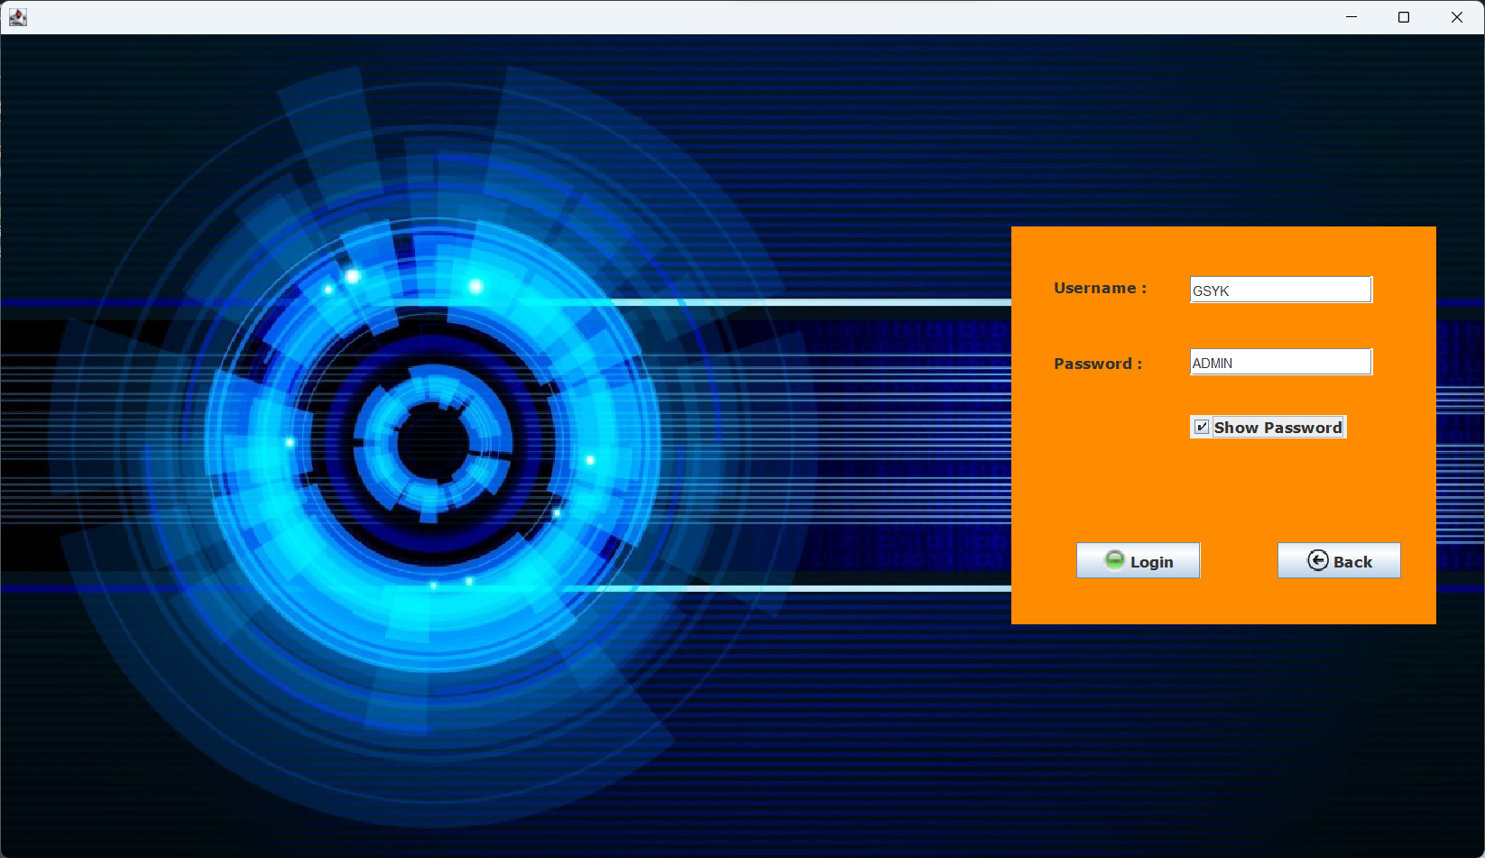

Admin Login Page

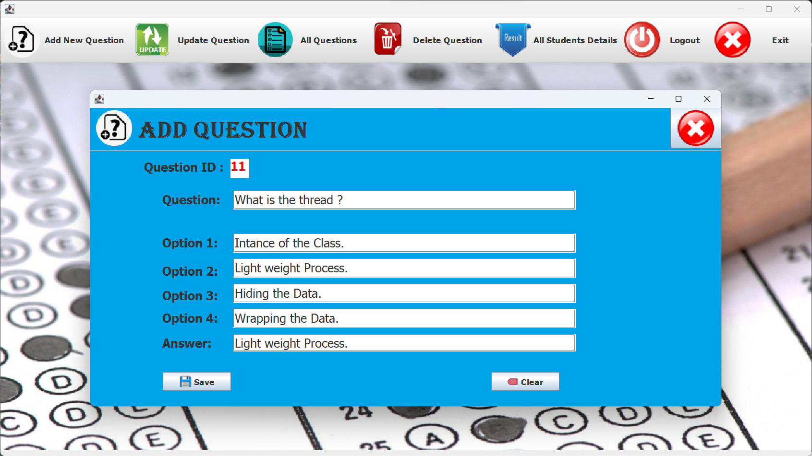Add Question Page

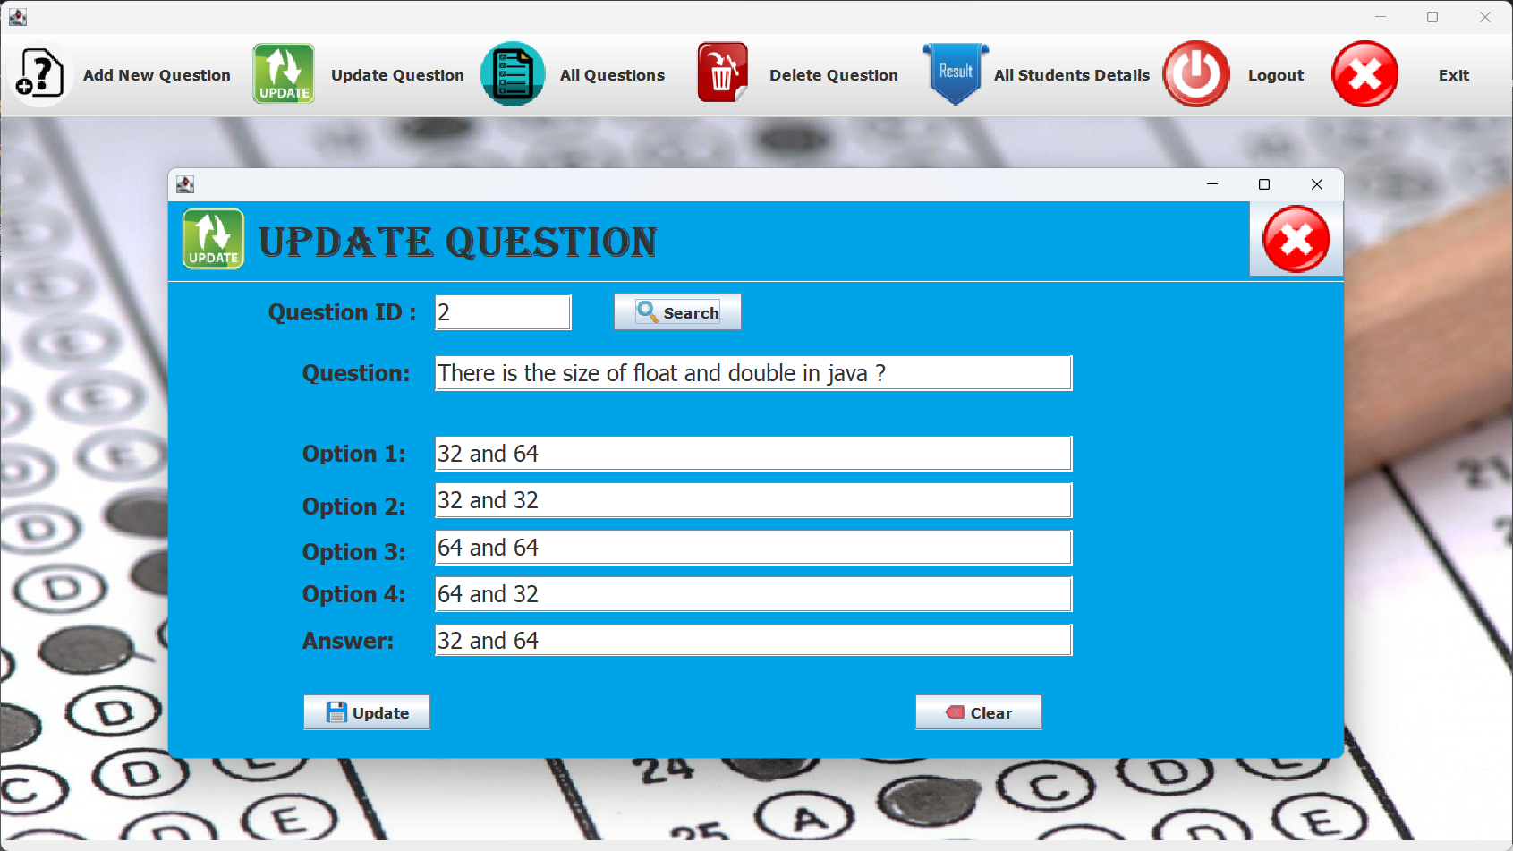

Update Question Page

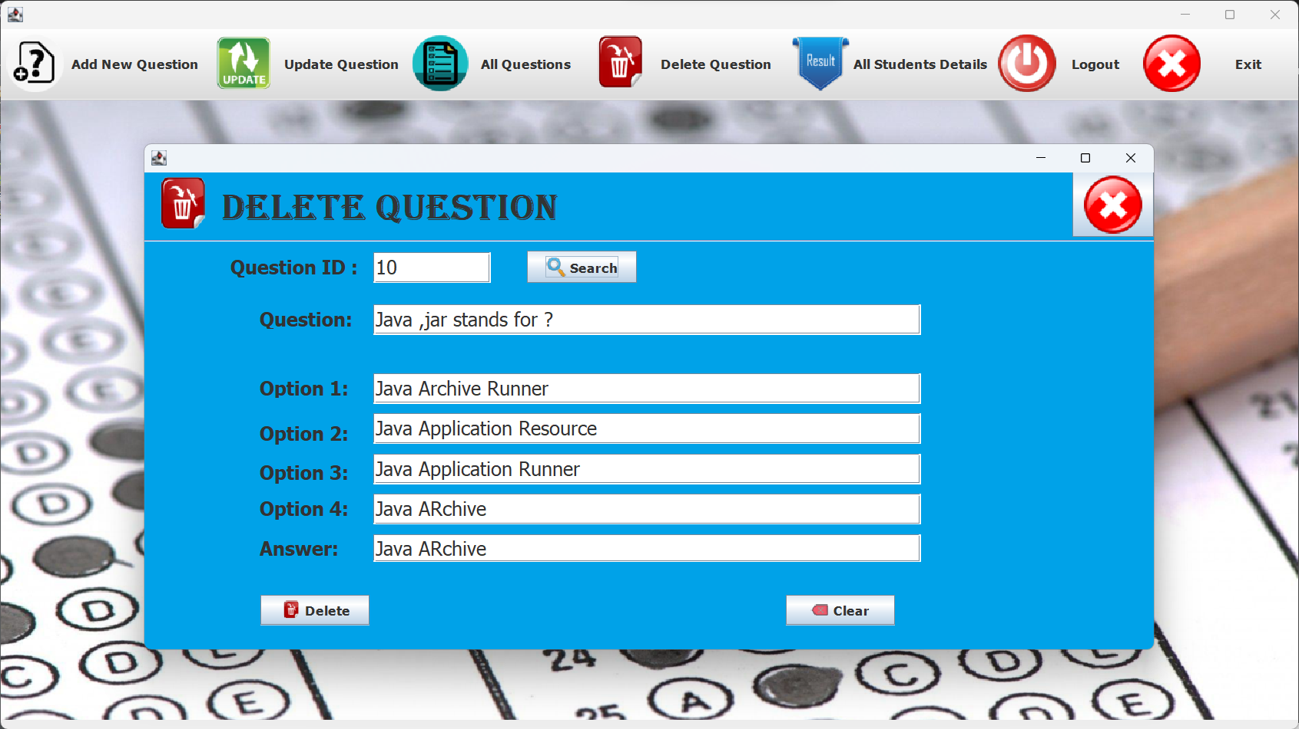

Delete Question Page

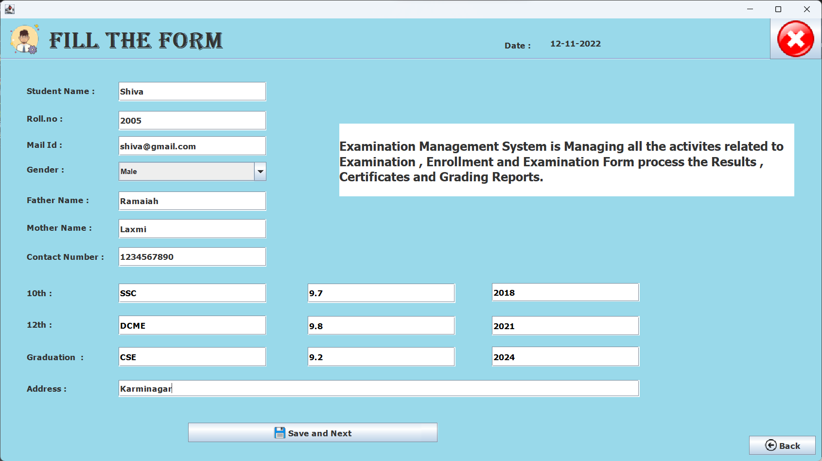

Student Registration Form

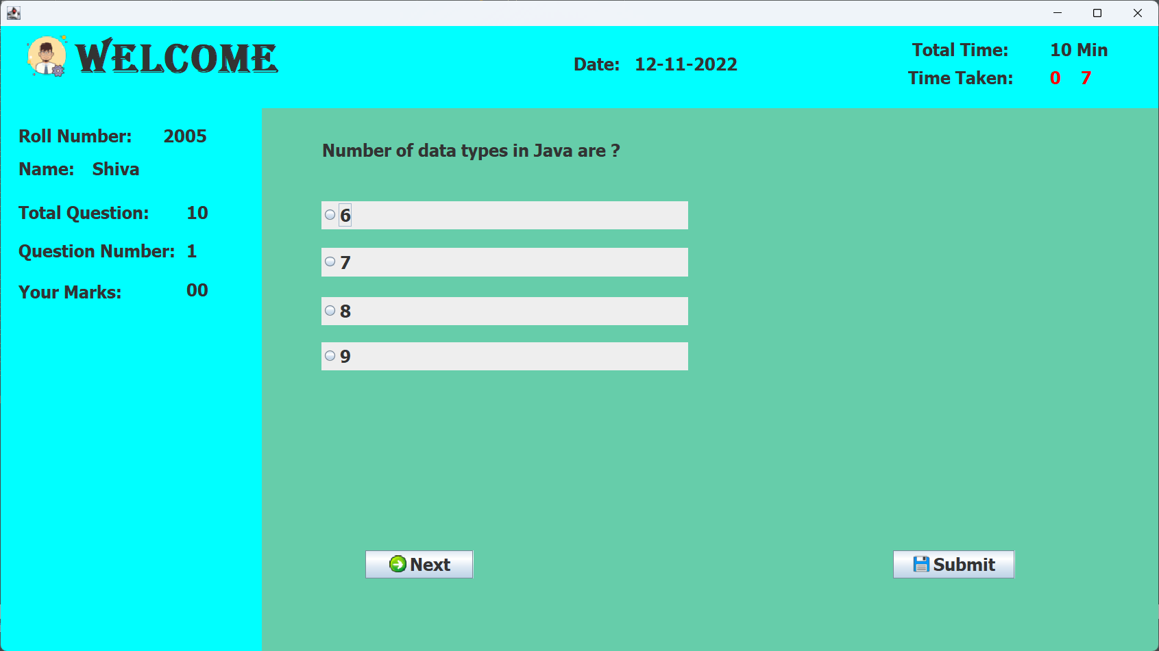

Student Quiz Page

1. **CONCLUSION**

This quiz application provides facility to play quiz anywhere and anytime. It saves time since user does need to wait for result. So student/user cannot wait for the result. All Student/ user get extra knowledge and skills. Administrator has a privilege to put as much as question in any category given in application. User can register , give the test and can see the results as well.